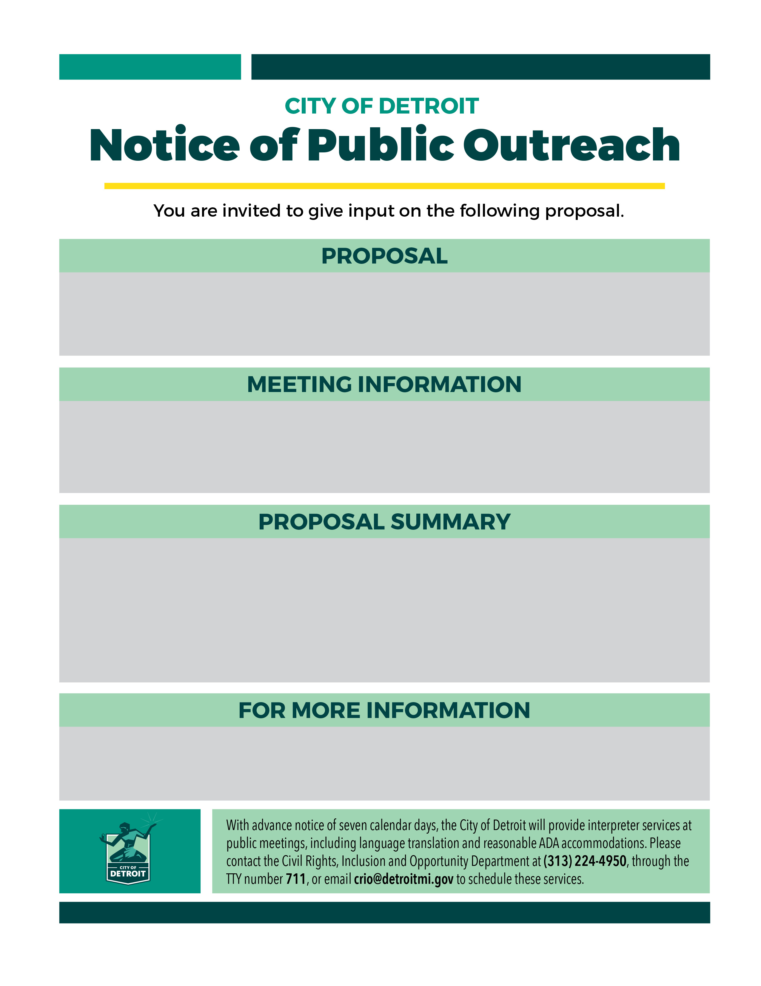
Please join the General Services Department for updates on the design and construction of the Joe Louis Greenway on Woodmere Street. This route was previously selected through a community-led process and will create a biking/walking connection between Fort Street and Vernor Highway.

The design for this 1-mile segment includes an off-street shared use path, road resurfacing, lighting improvements, and street safety interventions. Total costs will be $10.2m and are fully grant funded. Construction is planned for 2027.

Meeting 3 (online)
April 29, 5:00-6:00pm
Virtual Meeting Link:
https://cityofdetroit.zoom.us/j/83726031305

Meeting 2 (online)
April 21, 5:00-6:00pm
Virtual meeting link:
https://cityofdetroit.zoom.us/j/83726031305

Send feedback to joelouisgreenway@detroitmi.gov.
For information about the Joe Louis Greenway, visit www.joelouisgreenway.com.
Joe Louis Greenway: Woodmere Street Walking-Biking Paths

