
CITY OF DETROIT
PUBLIC ACTION PLAN FOR
COMMUNITY DEVELOPMENT BLOCK GRANT - DISASTER RECOVERY (CDBG-DR)

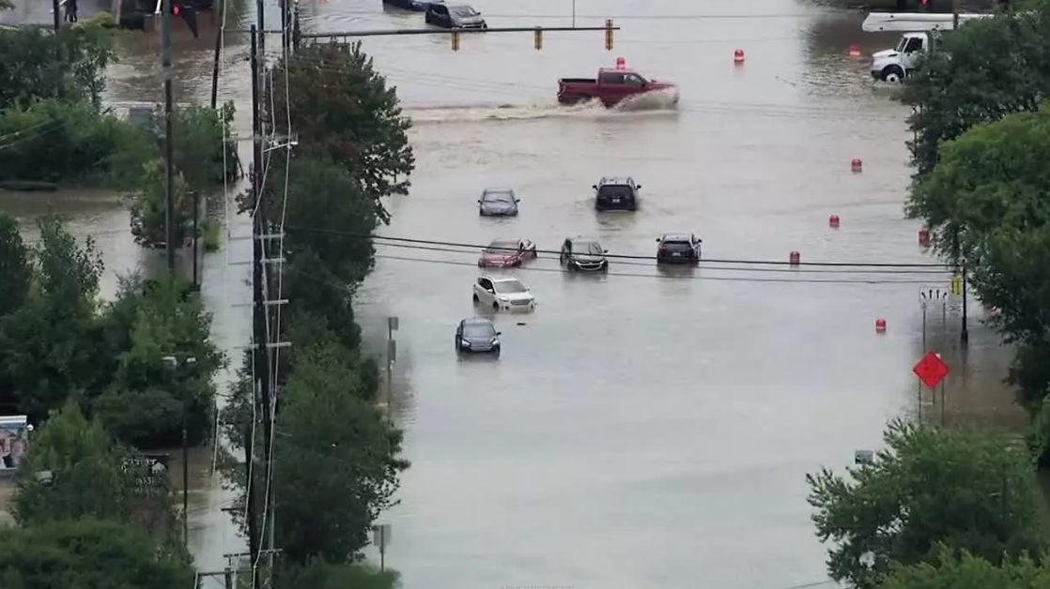
Julie Schneider, Director
Housing and Revitalization Department
Coleman A. Young Municipal Center
2 Woodward Avenue, Suite 908
Detroit, MI 48226

Mayor, Mike Duggan
Prepared by: Housing and Revitalization Department (HRD)
Substantial Amendment # 1: 9/17/25

ACTION PLAN CHANGE LOG
Action Plan submitted to HUD 9/17/2025
Action Plan approved by HUD 11/6/2025
Version (Date) | Summary of Changes Made | Substantial or Nonsubstantial
Amendment #1  8/6/2025 | Section IV – Housing: Affordable Public Housing Update includes update to eligible areas (from D1, D3, D5 to City-Wide), included Project Based Voucher Sites. Clarified DHC selection of developers versus contractors. (pg. 32)  Section IV – Housing: Down Payment Assistance $600,000 is being moved from the budget to a new Housing Activity specifically for housing and financial counseling – new budget of $9,400,000.  Section IV- Housing: New Activity Added – Housing Information and Referral Services in the amount of $600,000 for Detroit Financial Empowerment Centers. | Substantial

Contents
I. Executive Summary 5
Overview 5
Disaster Specific Overview 6
Most Impacted and Distressed Areas 8
Overview of the Impacts of the Qualifying Disaster 8
Unmet Needs, Mitigation Needs 12
II. Unmet Needs Assessment 13
Evaluate the Impacts of the Three Core Aspects of Recovery 13
Housing 13
Infrastructure 20
Economic Revitalization 21
III. Mitigation Needs Assessment 23
IV. Allocation and Award Caps & Funding Criteria 30
Administration 31
Planning 31
Housing 31
Housing Programs Overview 31
Grantee Housing Program Number One 32
Grantee Housing Program Number Two 33
Grantee Housing Program Number Three 34
Housing Program Number Four 37
Infrastructure 39
Infrastructure Programs Overview 39
Grantee Infrastructure Program Number One 39
Grantee Infrastructure Program Number Two 40
Grantee Infrastructure Program Number Three 42
CDBG-DR Mitigation Set-Aside 44
CDBG-DR Mitigation Set-Aside Programs Overview 44
Grantee CDBG-DR Mitigation Set-Aside Program Number One 46
Grantee CDBG-DR Mitigation Set-Aside Program Number Two 49
Grantee CDBG-DR Mitigation Set-Aside Program Number Three 50
V. General Information 52
Citizen Participation 52
Outreach and Engagement 54
Modifications to the Action Plan 55
Substantial Amendment 55
Nonsubstantial Amendment 56
Performance Reports 56
Complaints 56
VI. Exhibit A – Public Comments 58

Executive Summary

Overview
The U.S. Department of Housing and Urban Development (HUD) awarded the City of Detroit, through its Housing and Revitalization Department (HRD), $346,864,000 in funding to support long-term recovery efforts following 2023 Presidential Major Disaster Declaration (federal disaster declaration FEMA #4757 - Michigan Severe Storms, Flooding and Tornadoes). The Allocations for Community Development Block Grant Disaster Recovery (CDBG-DR) and Implementation of the CDBG-DR Consolidated Waivers and Alternative Requirements Notice, also known as the Allocation Announcement Notice (UN AAN) published January 16, 2025, made funds available to the City of Detroit by the Disaster Relief Supplemental Appropriations Act, 2025 (Public Law 118-158 also known as the “Universal Notice”) approved on December 21,2024.
Community Development Block Grant- Disaster Recovery funding is designed to address needs that remain following a Presidentially Declared Disaster after all other assistance has been exhausted. This plan details how funds will be allocated to address the remaining unmet need in Detroit, Michigan. To meet disaster recovery needs, the statutes making CDBG-DR funds available have imposed additional requirements and authorized HUD to modify the rules that apply to the annual CDBG program to enhance flexibility and allow for quicker recovery.
In January 2025, HUD allocated $346,864,000 in CDBG-DR funds to the City of Detroit, Housing and Revitalization in response to 2023 Presidential Major Disaster Declaration (federal disaster declaration FEMA #4757 - Michigan Severe Storms, Flooding and Tornadoes), through the publication of the “Universal Notice” in the Federal Register, Vol. 90, No. 5, January 8, 2025 (Updated March 19, 2025). This allocation was made available through the Disaster Relief Supplemental Appropriations Act, 2025 (Public Law 118-158) approved on December 21,2024. (These CDBG-DR funds are for necessary expenses for activities authorized under Title I of the Housing and Community Development Act of 1974 (42 United States Code [U.S.C.] 5301 et seq.3 (HCDA)) related to disaster relief, long-term recovery, restoration of infrastructure and housing, economic revitalization, and mitigation in the ‘‘most impacted and distressed’’ (MID) areas resulting from a qualifying major disaster in 2023.
To fulfill the requirements of this allocation, the City of Detroit must submit to HUD an Action Plan for Disaster Recovery that identifies its unmet recovery and resilience needs. This Action Plan outlines the proposed use of CDBG-DR funds and eligible activities available to assist impacted Detroit neighborhoods to meet unmet housing, infrastructure, planning, and other needs that have resulted from the impacts of subsequent flooding events due to heavy rains.
Specifically, this plan aims to promote and ensure access to housing for low-to moderate income residents, and strengthen neighborhoods impacted by the disaster by investing in housing and infrastructure.

Disaster Specific Overview
On August 24-26, 2023, Detroit experienced a 1 in 25-year rainstorm (0.01% probability), resulting in 2.4 inches of rain in a 1-hour period in some areas of the city. The average across the city was 1.5-3 inches of rain in 4 hours. This amount of rain exceeded the capacity of the city's infrastructure, which was designed to withstand 1.5-3 inches of rain in a 24hr period and was the root cause of flooding. The city estimates that around 5,000 households (majority low-to-moderate income) were directly impacted by the disaster.
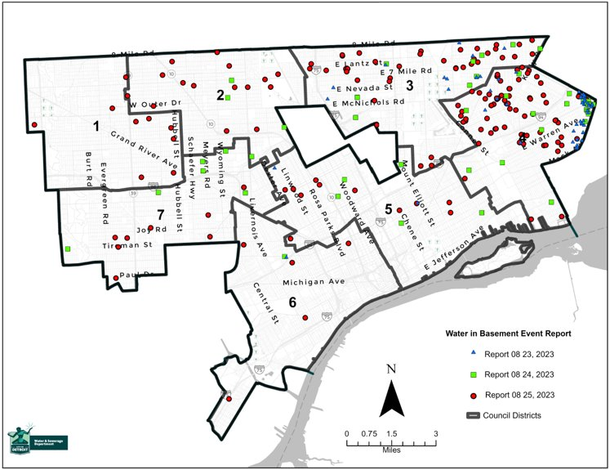
Water in Basement Event Report
Detroit Water and Sewerage Department report demonstrating water in basement reports from Detroit residents during the storm

The storm, which produced the torrential downpour, led to flooding on streets and freeways, as well as flooding in residential and commercial basements. In addition, flooding impacts also included collapsed sewer lateral service lines coming from single-family residences and capacity/failure to function issues with the city's combined storm water and sewer system.
The following conditions were not the primary cause of the flooding, but can be deemed as critical factors that exacerbated the impact based on analysis performed from previous flood events (including the most recent Presidentially Declared Disaster #4507 in June of 2021)-
- Limited Storm Water & Sewer Capacity - The City's combined storm water and sewer system was only designed to handle a 10-year storm, and the city was impacted by a 1 in 25-year storm event.
- Insufficient Green Stormwater Infrastructure - The City has limited green storm water infrastructure, and the infrastructure in place was not designed for this level of rainfall.

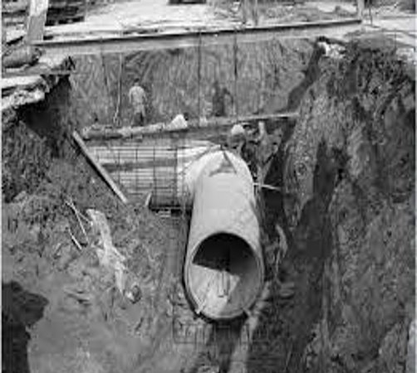
Historical Photo of Detroit Sewer System
The City of Detroit’s sewer lines were installed anywhere between 70-90 years ago and are unable to handle the amount of rainfall from rainstorms in the more recent decades.

​​

Most Impacted and Distressed Areas

HUD Identified MID Areas
HUD has identified the entire City of Detroit as a MID “Most Impacted and Distressed” area. In accordance with HUD guidance, the City of Detroit analyzed the impacts of the disaster to identify the level of citywide damage, which will be used as the basis for an unmet needs assessment and identification of priorities for CDBG-DR funding. During the storms on August 25-26, 2023, more than 2.4 inches of rain fell in a 1-hour period in some areas of the city, causing flooding of homes, businesses, streets, and highways.

Overview of the Impacts of the Qualifying Disaster

Based on the calculation of unmet needs provided by HUD utilizing FEMA Individual Assistance (IA) data, majority of the total unmet need for Detroit for the disaster equated to unmet Housing needs. That assessment correlated to the amount of FEMA Individual Assistance Claims received as a result of the disaster. There were 89,872 households who registered for FEMA IA, of which 77,904 households registered found to have some damage, almost all of which was basement flooding. Of the 77,904 households, 5,003 met the HUD threshold for seriously damaged. The City is waiting for complete information on for the FEMA IA data, but as a result of early data received, the City of Detroit has identified housing and infrastructure that supports housing as key activities for addressing the unmet needs.
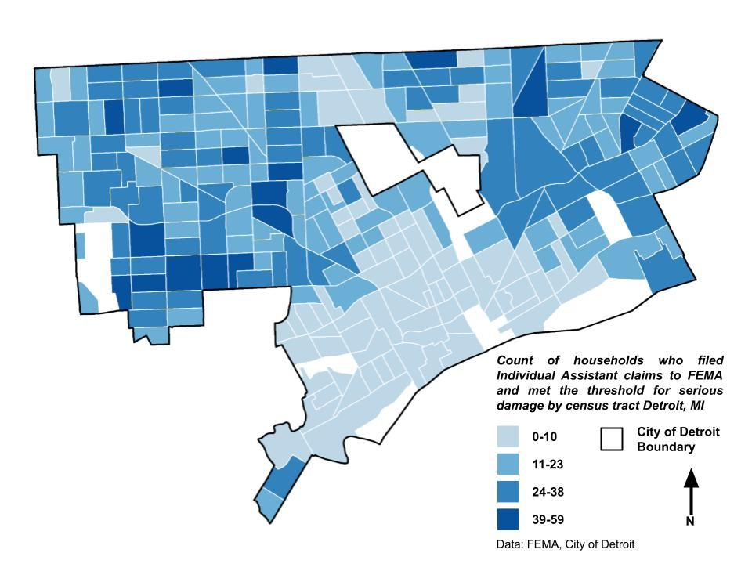
This map shows households who filed Individual Assistant claims to FEMA and met the threshold for serious damage.
The City has identified additional needs based on pre-disaster data. The level of unmet needs is significantly greater than the amount of funding available. Therefore, the City proposes activities that align with accessible funding and activities closest to the impacts of the disaster.
The City, through its Housing and Revitalization Department (HRD), anticipates delivering the proposed activities in coordination with the Detroit Water and Sewerage Department (DWSD), Detroit Department of Public Works (DPW), Detroit Housing Commission (DHC) and their contractors, subrecipients and developers.
The primary objective of this plan is to meet the needs of low- and moderate-income neighborhoods by preserving, rehabbing and/or constructing affordable housing units in the City of Detroit. Furthermore, the city proposed investing in infrastructure and public facilities activities both for recovery and mitigation, to provide flood protection and prevent such impacts from happening again in the future.
During the August 24-26, 2023, rain event, up to 2.4 inches of rain took several days to recede from basements and streets. In Michigan, specifically in Detroit, most families use their basements as family rooms or recreation areas and for storage, including for some of their most cherished belongings. Not only did the homes have basement backups in August 2023, but Detroit neighborhoods also had backups in June 2021 and June 2016 after a heavy rainstorm, and several neighborhoods across the city experienced basement backups and flooding in August 2014, with a rainfall of 4.57 inches.
However, due to the number of low-to-moderate income households in the city, most residents that continue to have basement backups are unable to install a backwater valve and maintain their sewer lines, which is why the City launched the Basement Backup Protection Program (BBPP) in May 2022 (funded with $6.4MM in American Rescue Plan Act funding) and the Private Sewer Repair Program (PSRP) in January of 2024 (funded with $43MM of 2021 CDBG-DR funding). The impacts of these programs will increase the resilience of the single-family housing stock and decrease city-wide repetitive loss. The BBPP program served 704 households in 11 target neighborhoods. The City continues to serve residents through the PSRP by repairing or installing new sewer laterals for eligible households. As of February 2025, the PSRP program has served 404 households, with a goal of 1,500.

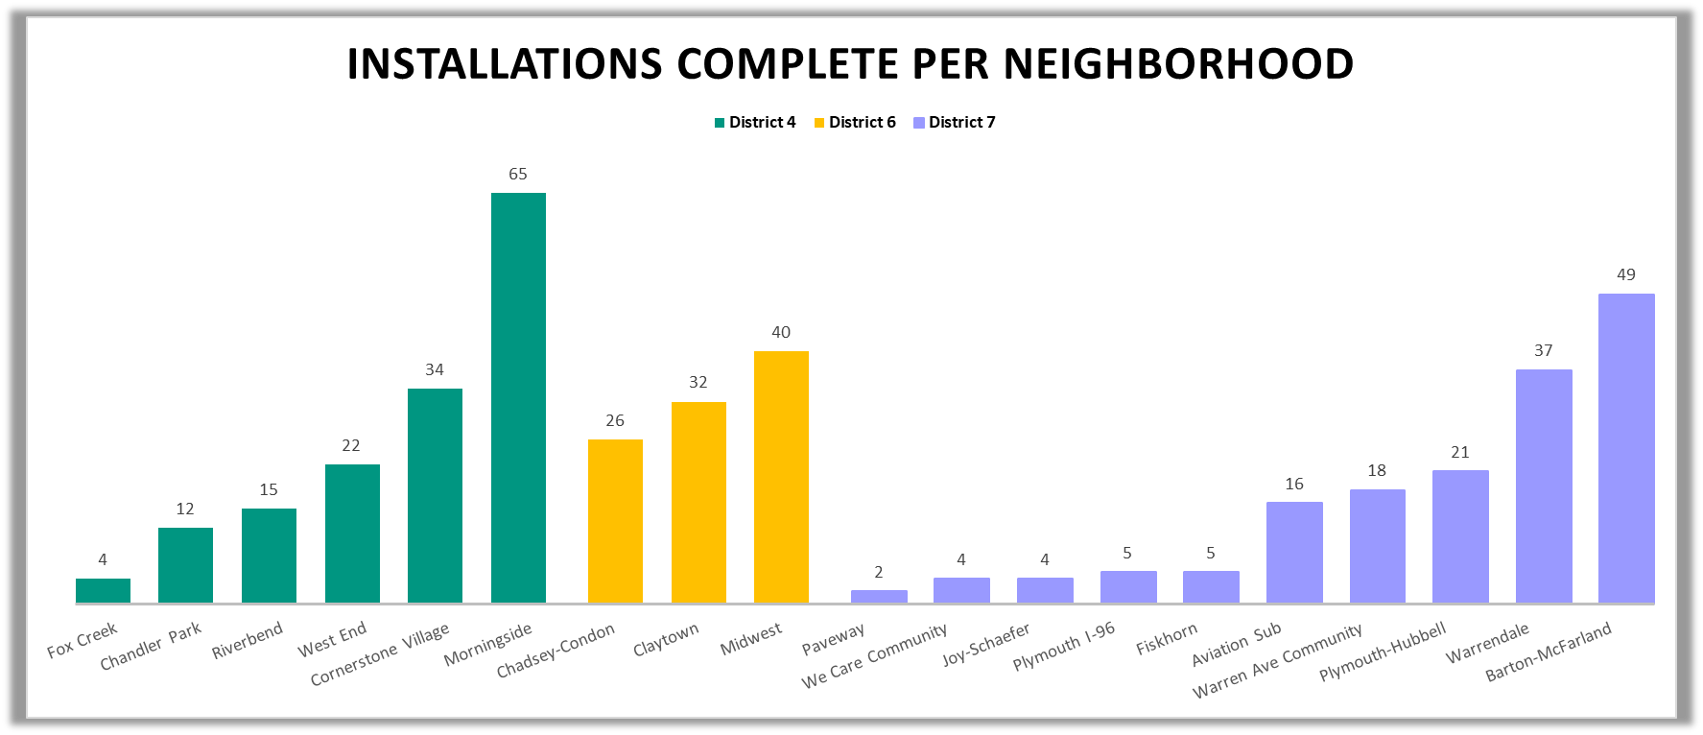 PSRP Installations completed per neighborhood as of February 2025
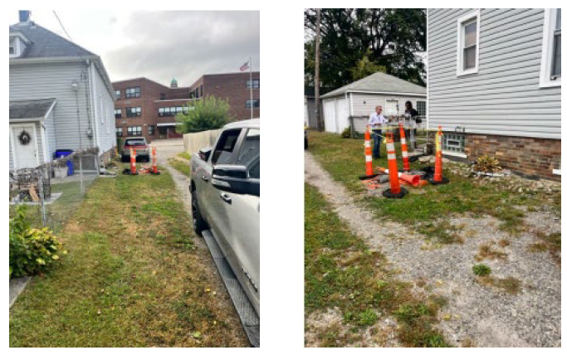
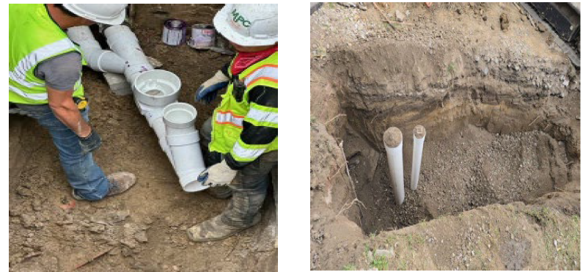
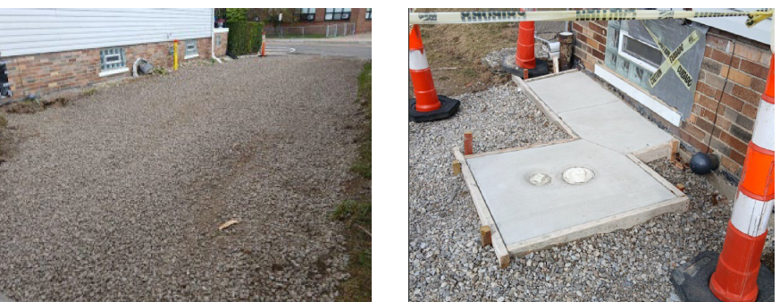
Before, During and After photos of PSRP work in the City of Detroit.

Table 1A: Disaster Overview
Disaster Summary
Qualifying Disaster: | Michigan Severe Storms, Tornadoes and Flooding (DR-4757-MI)
HUD-identified MID Areas: | City of Detroit, Michigan
Grantee-Identified MID Areas | N/A

Table 1B: CDBG-DR Allocation Overview
CDBG-DR Allocation Overview:
CDBG-DR Allocation: | $301,621,000
CDBG-DR Mitigation Set Aside: | $45,243,000
Total Allocation: | $346,864,000

Unmet Needs, Mitigation Needs

Table 1C: Unmet Needs and Proposed Allocations
Eligible Cost Category | CDBG-DR Allocation Amount | % of CDBG-DR Allocation | Estimated % to CDBG-DR Mitigation Set-aside | Estimated % to HUD identified MID Areas | Estimated % to LMI
Administration | $17,343,200 | 5%
Planning | $2,000,000 | 1% | 0%
Housing | $73,000,000 | 21% | 0% | 100% | 100%
Infrastructure | $209,277,800 | 60% | 0% | 100% | 100%
Economic Revitalization | 0% | 0% | 0% | 0% | 0%
Public Services | 0% | 0% | 0% | 0% | 0%
Exempt Public Services | 0% | 0% | 0% | 0% | 0%
CDBG-DR Mitigation Set-Aside | $45,243,000 | 13% | 13% | 100% | 100%
Total | $346,864,000 | 100% | 13% | 100% | 100%
% of Total | 100% | 100% | 13% | 100% | 100%

Unmet Needs Assessment

Evaluate the Impacts of the Three Core Aspects of Recovery

The City of Detroit, through its unmet needs assessment, identified various unmet disaster recovery needs, especially related to Housing and Infrastructure. It is important to note that the City used local data, and as additional data from federal sources are shared, the City will update its Unmet Needs Assessment accordingly. Many residential neighborhoods and public facilities experienced basement backups due to a variety of factors, including but not limited to, rain events beyond the capacity of the existing public sewer system and private infrastructure such as collapsed or cracked sewer lateral service lines attached to houses. These issues can exacerbate a significant rain event that causes basement backups. In addition, the city experienced flooding of highways and streets due to aging infrastructure and documented changes in precipitation patterns. Public facilities such as emergency shelters experienced flooding which forced some shelters to close and move to temporary locations.

Housing

While the disaster led to many unforeseen circumstances for Detroit residents, the housing unmet needs predate the date of the disaster. While housing costs in Detroit are low compared to the surrounding region, housing affordability remains a major challenge due to the lower incomes of many Detroit households. Rents have grown by an average of 4.5% annually in Detroit since 2019. Median gross rent was $1,043 in Detroit in 2023, compared to $1,183 in the Metro Detroit area and $1,406 nationally. This rent growth outpaces growth in median income, making affordable housing options increasingly unattainable for the lower-income Detroit families. Around 60% of renters in Detroit are considered extremely low-income and earn $35,000 or less annually. In 2023, 39% (roughly 100,000) of Detroit households were cost burdened (meaning they paid more than 30% of their income on housing) at the time of the disaster (ACS 2023). Extremely low-income households are disproportionately impacted by rising housing costs, leaving fewer resources for other critical expenses such as food, transportation, and childcare. Consequently, disaster recovery expenses fell on homeowners and renters already experiencing economic hardships.

Housing Cost Burdened Households by Income (ACS 2023)
Household Income | Cost Burdened | Not Cost Burdened | Cost Burdened %
<$20,000 | 52,249 | 3,943 | 87%
$20,000-$34,999 | 26,268 | 16,438 | 62%
$35,000-$49,999 | 13,089 | 22,541 | 35%
$50,000-$74,999 | 6,630 | 29,571 | 18%
$75,000+ | 2,085 | 60,417 | 3%

The scale of housing challenges related to the disaster were exacerbated by the age of the housing stock in Detroit. More than 58% of the housing stock in Detroit was built prior to 1950 and 92% was built prior to 1980. Housing units of this age were generally not built with disaster/weather related resiliency design considerations. Further, the infrastructure built/installed at the time of housing construction has aged and is prone to failure when stressed by extreme weather events. As this housing stock faces high incidences of deferred maintenance, investments are needed to prevent new vacancies and reduce unsafe living conditions for residents.

Timeframe Built | # of Units | % of Total Units
2000 or later | 13,620 | 4%
1980-1999 | 13,722 | 4%
1950-1979 | 109,674 | 33%
Prior to 1950 | 195,245 | 59%

Detroit has approximately 25,000 rental housing units that are rent- and income-restricted to serve as affordable housing for extremely low- to low-income residents (approximately 20% of rental housing units). Households in these units may be at risk as the subsidy/restrictions expire, and/or the limited cash flow contributes to deferred maintenance and deterioration over time. HRD is currently tracking 2,400 regulated affordable housing units that are at risk of losing affordability restrictions over the next five years including expiring LIHTC units and Section 8 contracts up for renewal.
To meet substantial needs, Detroit must not only preserve its existing affordable housing but add supply through new housing production. The cost of construction in Detroit has been historically high relative to other parts of the state, and recent challenges such as construction costs that have increased by 41% since 2021 and interest rates that have increased by more 4.5 percentage points from 2022 to 2024 have exacerbated the problem. With few exceptions, all new housing construction requires subsidies, and the finite subsidy tools available currently limit production.
Assisting low-income households access the homebuying market has been an effective strategy to address the demand for affordable housing, particularly among larger households. Compared to the national landscape, Detroit’s homebuying market continues to be relatively affordable with principal, interest, taxes and insurance (PITI) often below typical affordable rent levels. The City has paired Down Payment Assistance with HUD pre-purchase counseling to bridge the homeowner readiness gap for Detroit residents. In 2022-2024, the City used temporary ARPA funding to launch the Detroit DPA program to reduce the gap between what households earn and the housing they can afford to purchase. The average monthly housing payment for participants in the Detroit DPA program was $926 (inclusive of mortgage principal and interest, property taxes and homeowners insurance). The MSHDA affordable rent limit in Wayne County for a 3 bedroom housing unit and a household at 60% AMI is $1,575 per month (minus tenant-paid utilities), demonstrating that Down Payment Assistance is an effective strategy to subsize affordable housing and reduce housing cost burden for a portion of Detroit residents.

Emergency Shelters, Interim, and Permanent Housing

Disaster recovery must consider the needs of people experiencing homelessness as many formal supports (shelters and supportive services) and informal supports (e.g., community resource sharing) may be impacted. To review the unmet need for homelessness in Detroit, the 2023 Point in Time count was reviewed. The Point In Time (PIT) count measured the number of sheltered and unsheltered people experiencing homelessness on a single night in Detroit (2023 Detroit Continuum of Care Point-in-Time Count Detailed Data Report).
As shown in the table below, the City of Detroit could estimate on any given night in 2023, 1,280 or more people are experiencing sheltered homelessness, 1,069 staying in emergency shelters and 211 transitional housing. The Detroit Continuum of Care (CoC) is required to conduct an unsheltered Point-in-Time count every other year and was not required to complete one in 2023, however in 2022 there were 202 or more people experiencing unsheltered homelessness- living on the street, or staying in a place not meant for human habitation (2023 Detroit CoC Point-in-Time Count Detailed Data Report).

City of Detroit Point in Times Count Results 1/26/2023
City of Detroit Point in Times Count Results 1/27/2021
 | Sheltered
CoC | Emergency Shelter | Transitional Housing | Unsheltered | Total Households
2023 | 1,069 | 211 | N/A* | 1,280
2022 | 1,279 | 210 | 202 | 1,691
*An unsheltered PIT Counts was not conducted in 2023 due to it being required every other year. An unsheltered PIT was conducted in 2022.

City of Detroit Total Year-Round Housing Inventory Count by CoC
City of Detroit Total Year-Round Housing Inventory Count by CoC
CoC-501 | Emergency Shelter Beds | Transitional Housing Beds | Total Beds
2023 | 1,019 | 234 | 923
2022 | 991 | 279 | 1,270
Source: 2023 Detroit CoC Housing Inventory Count, Summary Data Report

It is important to note, the City of Detroit does not operate any homeless shelters. However, several are Subrecipient non-profit organizations that receive CDBG public service and Emergency Solution Grant (ESG) funds that provide emergency homeless prevention by way of transitional housing for the most vulnerable population. This plan proposes supporting Emergency Shelters improvements as a public facility activity.
Public facilities such as emergency shelters experienced flood damage. In 2023, the City of Detroit funded 959 emergency shelter beds, consisting of 14 year-round shelters and 3 warming centers. The 2023 disaster impacted several emergency shelters. Three shelters sustained damage to their buildings that did not result in a loss of beds but changes in operations such as having to relocate where meals were served, residents being unable to do laundry until the flooding was fixed, and areas of the building that couldn't be accessed. An additional shelter had damaged supplies and furniture which had to be disposed of.
Recognizing the City’s long and well-documented infrastructure challenges, as well as its ongoing efforts to mitigate future flooding in our most vulnerable areas, the City of Detroit is committed to rebuilding resiliently. In assessing unmet needs, it is important to consider the additional costs of safeguarding housing and community development investments from future disasters. It is especially important to support shelters as they have limited options for rehabilitation funding and are operated by non-profits who may struggle with capital campaigns.

Rental and Owner-Occupied Single Family and Multifamily Housing

The housing stock in the City of Detroit is comprised overwhelmingly of detached, single-family houses. ACS 2023 data estimates show that roughly 71% of Detroit’s housing stock was single-family houses, nearly all of which were detached dwellings. Detached duplexes are also a standard of Detroit’s housing typology, but the ACS found that duplexes accounted only for another 5.4% of the overall stock. Single-family homes are most distressed stock and most susceptible to becoming obsolete after a flooding event.
However, unlike typical detached single-family neighborhoods across the United States, in Detroit, many residents of such neighborhoods rent. This is in large part an outcome of the foreclosure crisis and Great Recession. In 2021, an estimated 49% of occupied Detroit housing units were renter-occupied.
The number of low- and moderate-income cost burdened renter households has nearly doubled since 2010. While extremely low-income renter households have declined, it may be indicative of their inability to find affordable housing within the city. Rent growth rate in the city is larger than the Metropolitan Statistical Area (MSA). Between 2019-2021 the City of Detroit annual rent growth was 4.5% while the MSA was only 4.0%.

Renters earning less than $35,000 face a substantial rental supply gap. Between 2016 and 2021 the City of Detroit lost over 32,000 rental units affordable to low-income families earning less than $40,000 annually.

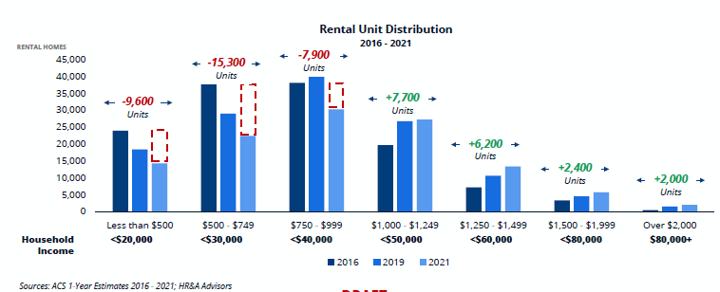

The City is losing the low rent and naturally occurring affordable housing units. These units have deferred maintenance in general, and flooding events likely cause low rent units to go vacant.
The proposed activities will improve access to safe and healthy housing for low-to-moderate (LMI) people who otherwise do not have access to the resources to prevent the impacts of disasters such as these. LMI Detroit residents can face unique challenges and have more difficulty responding to disaster events than the general population due to physical and financial capabilities, health concerns, and location and quality of their housing, among other factors.

Pre-Disaster Renter and Owner-Occupied Housing for 2023
 | Renter -Occupied (#) | Renter -Occupied (%) | Owner - Occupied (#) | Owner - Occupied (%) | Vacancy Rate (%)
City of Detroit | 118,290 | 36% | 137,567 | 41% | 23%

Over 22% of Detroit’s existing housing stock remains vacant. Single-family detached and attached units make up 54% of renter occupied residential units. Single-family housing continues to be the backbone of Detroit’s housing supply, housing over two-thirds of residents.

Detroit’s multi-family housing stock has declined over the past decade. These are mostly naturally affordable and often house family households.

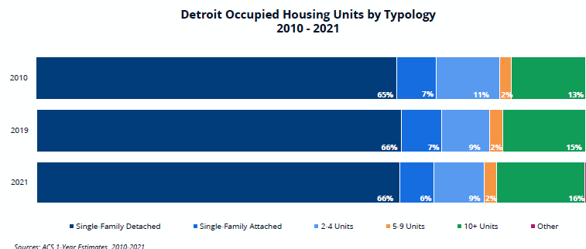

Public Housing (Including HUD-assisted Housing) and Other Affordable Housing

The federal government defines affordable rents as housing costs that do not exceed 30% of a household’s monthly income. For renters, these costs include rent and basic utilities (electric, gas and water). There are two basic types of affordable rental housing in Detroit:
- Naturally occurring: This type of housing is not government regulated but is considered affordable to households at market rate because costs amount to less than 30% of their monthly income.
- Regulated: This type of housing is subsidized by government programs to ensure that low-income households do not pay more than 30% of their income on rent, or that rents are restricted at a level that is affordable for low-income households.
There are two broad categories of regulated affordable housing:
- Public Housing: Owned and operated by Detroit Housing Commission.
- Other regulated housing: Privately owned but offer affordable rents for low-income tenants.
The City of Detroit was in the midst of an affordable housing crisis prior to Disaster. Cost burden and lack of affordable housing were identified as one of the housing issues faced by the City. At the time, more than 100,000 households had rent and other expenses exceeding 30% of the household income. The City of Detroit has identified a significant need for affordable units for family households with children and no spouse and for single person households. About 60% of Multifamily naturally occurring affordable housing (NOAH) units are 1-bedroom units. There are limited number of larger NOAH units, challenging the ability of lower-income families in finding housing. In the next five years, nearly 3,000 affordable housing units funded through LIHTC will lose their affordable requirements without further intervention.

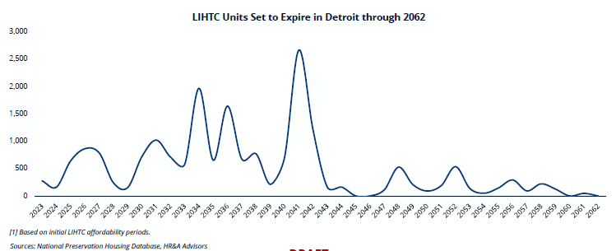

Infrastructure

​The City of Detroit experienced a 25-year storm in August of 2023. The City's infrastructure is built for a ten-year flood, and the disaster pushed existing systems over their capacity. The Detroit Water and Sewerage Department (DWSD) routinely maintains sewer-catch basin cleanout throughout the city. This is important because there is a combined sewer system where all sewage from residential, commercial, and industrial sources flow to the same place. Fluctuating lake levels add pressure to the sewer system. If there is a rise in lake or river levels, that water may also flow to the sewer system. Changing precipitation patterns, fluctuating Detroit River levels past flood stages, and aging infrastructure present immediate and significant challenges to the combined sewer system.
Detroit’s impervious surfaces cause stress on the sewer system by funneling stormwater into sewers instead of absorbing it into the ground. In addition, much of the surrounding counties drain through the City of Detroit, making Detroit the bottom of the water shed. Based on a sample of DWSD customers, approximately one-third of the houses in Detroit have compromised lateral connections. While many key wastewater pumping stations have had upgrades to their electrical supply recently, some still have an inconsistent, weak power supply. Consequently, heavy rain events, like the storm in August 2023, can cause all combined sewage and rainwater to overflow into basements, residential streets, and local highways.
Infrastructure improvements as one of the City's recovery and mitigation projects will be developed in a manner that considers an integrated approach to housing, infrastructure, economic revitalization, and overall community recovery. The City of Detroit will continue to work with Federal, State and neighboring local jurisdictions to provide guidance on promoting a sound short-and-long term recovery plan in the affected areas by coordinating available resources to help in the restoration and recovery of damaged communities. Disaster recovery presents affected communities with unique opportunities to examine a wide range of issues such as housing quality and availability the adequacy of existing infrastructure.

Economic Revitalization

​​The disaster’s impact on businesses is believed to be less severe than its impact on housing. Early FEMA and SBA claims data show that residential areas comprised a majority of the impact area. In addition, businesses are also more likely to carry insurance for the damage they incurred. As data is received related to economic development impacts, this Action Plan will be updated to reflect that information. The City of Detroit requested data from the Small Business Administration, and will update this plan to reflect that data as soon as it is made available. If this data shows that there should be a change in the proposed activities, the City will follow its substantial amendment process listed in Section V- General Requirements, of this plan.
The hardest hit areas of the MID were residential neighborhoods, not job centers or entertainment destinations. Most economic activity in Detroit neighborhoods is retail-oriented, a sector that has suffered for decades dating back to the mid-1900s when retail flight followed a significant population shift to suburban cities and townships. Since then, institutional barriers in the financial industry and elsewhere have suppressed the retail economy in Detroit. As a result, retail businesses in Detroit neighborhoods are few and Detroiters often shop in the suburbs or online to meet their needs. Hence, the impact of the disaster on businesses was limited.

Table 2A: Quantified Disaster Impacts and exacerbated Pre-Existing needs of Housing, Infrastructure, and Economic Development, Other Financial Assistance, and Remaining Unmet Need
Cost Categories | A  Direct and Indirect Need | B  Financial Assistance Budgeted and Obligated | A-B  Unmet Need
Rental Housing* | $30,296,942,000.00 | $25,000,000.00 | $30,271,942,000.00
Owner-Occupied Housing** | $27,500,000.00 | $0 | $27,500,000.00
Infrastructure*** | $1,200,000,000.00 | $0 | $1,200,000,000.00
Economic Development | Unknown | Uknown | Uknown
Total | $31,524,442,000.00 | $25,000,000.00 | $31,499,442,000

Estimated Affordable Rental Housing Unmet Need*
Number of Cost Burdened Households | 100,321 | ACS 2023
Average Cost of Affordable Housing Unit | $302,000 | HRD analysis of recent multifamily development activity (studio, 1-Br, 2-Br)
Total Cost of Unmet Affordable Housing Need | $30,296,942,000 | Cost burdened households x average unit cost
Average gap financing required | $40,200 | HRD analysis of recent multifamily development (studio, 1-Br, 2-Br)
Total Cost of Subsidy Needed for Unmet Affordable Housing Need | $4,032,904,200 | Cost burdened households x average gap

Estimated Affordable Homeownership Unmet Need**
Number of Low- & Moderate-Income Home Purchases Annually (Estimate) | 1,100 | HMDA & Detroit Future City
DPA per transaction | $25,000 | HRD
Total Cost of Unmet Affordable Housing Need | $27,500,000 | LMI home purchases x DPA

Estimated Infrastructure Unmet Need***
An estimated 65,400 (30%) of the 218,000 residential sewer connections have varying degrees of failure. The failures are either significantly offset, collapsed, or completely plugged with roots and debris to the extent that trenchless rodding is no longer feasible. | The estimated cost per connection is $20,000, as majority of these connections are located between 12 to 15 feet deep. | 65,400 laterals X $20,000/ea = $1,200,000,000

It is important to note that while the City is proposing the majority use of CDBG-DR for infrastructure, even though the unmet needs show housing as the greatest need, the repair and replacement of the infrastructure is important to address the impact of flooding on housing, ultimately supporting the housing unmet needs.
The City of Detroit did not receive any FEMA Public Assistance funds for this disaster.

Mitigation Needs Assessment
​​
As required by HUD, the City of Detroit developed a mitigation needs assessment based in part on the FEMA approved City of Detroit Hazard Mitigation Plan. This assessment addresses current and future risks, including hazards, vulnerability, and impacts of disasters and identifies appropriate mitigation actions to reduce the highest risks that Detroit faces.
The goal of the Hazard Mitigation Plan (HMP) is to minimize or eliminate long-term risks to human life and property from known hazards by identifying and implementing cost-effective hazard mitigation actions. The City of Detroit’s HMP extensively reviews alternatives and designed strategies that would work best for the City. The plan provides carefully considered directions to City government by studying the overall damage potential and ensuring that funds are well spent.
Hazard mitigation does not mean that all hazards are stopped or prevented. It does not suggest complete elimination of the damage or disruption caused by such incidents. Natural forces are powerful, and most natural hazards are well beyond our ability to control. According to the Federal Emergency Management Agency (FEMA), hazard mitigation includes any sustained action taken to reduce or eliminate long-term risk to life and property from future disasters. Every community, including Detroit, faces different hazards and has different interests and resources to bring to bear to address its problems. As there are many ways to deal with natural hazards and many agencies that can help, there is no one solution to managing or mitigating their effects.
Located in southeastern Michigan, Detroit is the largest city in Michigan, and the 26th largest city in the United States in 2020. Founded in 1701, the city was named the Ville d’Etroit or “City of the Strait” because of its position on the Detroit River. The Detroit River separates the City of Detroit from the City of Windsor, Ontario and serves as an international boundary between the United States and Canada.
Detroit is on the northern banks of the Detroit River and south of Lake St. Clair. The land area of Detroit comprises 138.7 square miles and has an elevation that ranges from 570.52’ to 589.94’ North American Vertical Datum (NADV), as measured at the Detroit River.
Due to the increase in developments across the City of Detroit, floodplains are impacted which contributes to flooding being a major hazard in Detroit. Prior to the developments, rainfall could more easily simply soak into the ground or slowly find its way to the river. With impervious surfaces the rainfall runs off quickly to the streets and man-made channels and pipes. Floods cause significant damage to public and private property, disable utilities, make roads and bridges impassable, destroy crops and agricultural lands, cause disruption to emergency services, and result in fatalities.
The Detroit HMP developed a risk assessment to rate the likelihood of any disaster harming Detroit. Below charts 1, 2, and 3 illustrate Flooding as the greatest hazard risk for the City of Detroit.

Chart 1. Hazard Risk
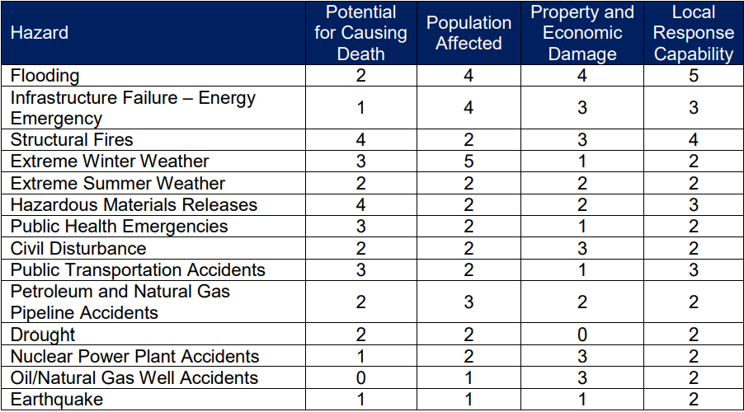

Chart 2
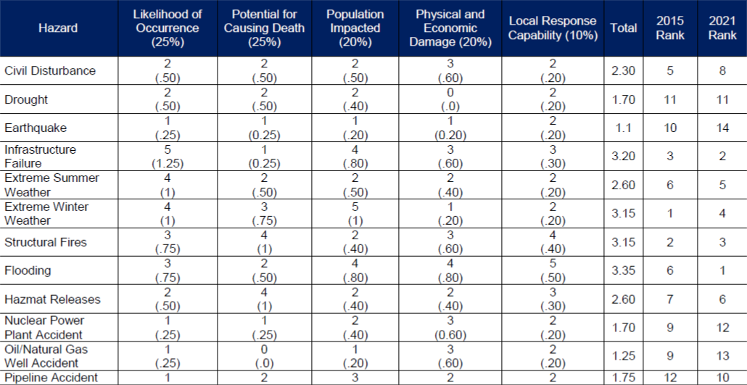
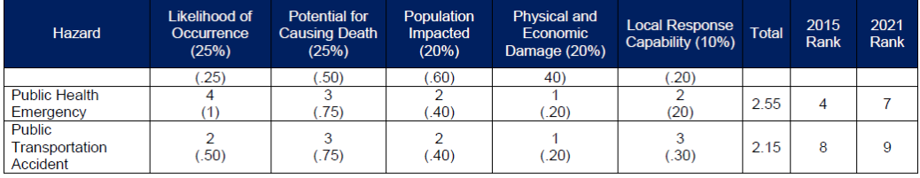

Chart 3. Significant Natural Hazard
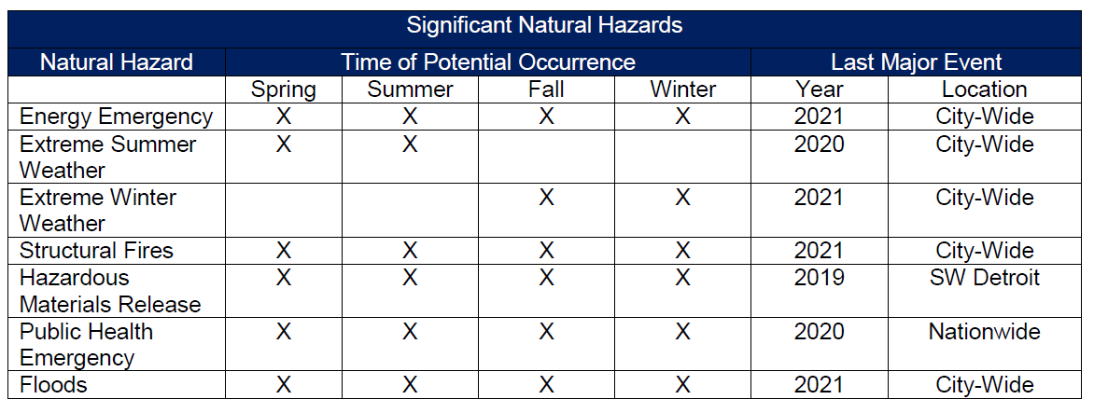
As the risk assessment tables demonstrate, flooding is at the forefront of Detroit’s hazard risks. Consequently, mitigation activities will be geared towards reducing the potential losses and preventing Detroit’s vulnerability to flood disaster events.

Hazard & Vulnerability Risk Analysis
Flood Insurance History
The City of Detroit has been a part of the National Flood Insurance Program (NFIP) since 1974 with an initial Flood Insurance Rate Map (FIRM) identified in 1981. In 2017, the City joined the Community Rating System (CRS) and maintains a Class 8 rating.
According to NFIP, there are 403 policies in force in Detroit. These policies provide insurance worth $82,121,200 as of 2021. The NFIP Repetitive Loss/Severe Repetitive Loss data provided indicates a total of 64 RL/SRL properties with a net total claim of $1,437,151.30. The National Center for Environmental Information (NCEI) estimates total property losses for a 15-year period to be $169,600,000 for an average loss of $11.3 million per year. These figures would suggest that adequate coverage is provided to those who would be most impacted by river flooding in Detroit. According to NOAA, the River Rouge crested above flood stage in Detroit on 41 occasions between 1968 and 2021. When combined with other flooding events recorded through NCEI records, such as heavy rain or snow melt, the city has experienced 2.96 flooding events per year since 1978.

Most Recent Disaster
Prior to the August 2023 event, in June 2021, the City of Detroit was impacted by a significant amount of rainfall. On June 25-26, 2021, Detroit experienced a 1 in 1,000-year rainstorm (0.01% probability), resulting in 6-8 inches of rain in a 12-hour period in some areas of the city. This amount of rain far exceeded the capacity of the city's infrastructure, which was designed to withstand 1.7 inches of rain in a one-hour period and was the root cause of flooding. Between 32,000 - 47,000 households (majority (82%) low-to-moderate income) were directly impacted by the disaster.
In addition, in August 2014, the City of Detroit had unusually frequent and extreme amounts of rainfall that created flood conditions in the Metropolitan Detroit area. The National Weather Service said that the total of 4.57 inches of rain that fell for the day is the second heaviest calendar-day rainfall on record in Detroit at the time, after the 4.74-inch rainfall of July 31, 1925. The flooding closed major freeways, hospitals, businesses, schools and government offices. This storm has been categorized by some weather experts as a 100-year type of event. Almost 10 billion gallons of sewer overflows poured into southeast Michigan's waters in the historic August flooding, according to a Detroit Free Press review of data from the Michigan Department of Environmental, Great Lakes and Energy. More recently, FEMA announced that federal disaster assistance has been made available to the state of Michigan to supplement recovery efforts in the areas affected by severe storms, tornadoes and flooding from Aug. 24-26, 2023.

Conclusion of Mitigation Needs Assessment
This Mitigation Needs Assessment makes it clear that historically, flooding has been a major hazard for the City of Detroit. By characterizing the hazard in terms of its frequency and the City's vulnerability, the City can draw on this needs assessment and the HMP to identify current and future flood hazards throughout the City of Detroit and target CDBG-DR funds toward cost-effective solutions to mitigate flooding over the long term. In addition, this assessment further supports proposed CDBG-DR mitigation activities undertaken as part of this allocation so that, at a minimum, they do not exacerbate hazards but rather serve to lessen their impacts.

Table 3A: CDBG-DR Mitigation Set-Aside Needs Assessment
CDBG-DR Mitigation Set-Aside Needs Assessment:
Categories Affected | A  Total  Need | B  Financial Assistance Budgeted and Obligated | A-B  Unmet Need
Housing* | Uknown | Uknown | Uknown
Infrastructure** | $1,244,900,000.00 | $0 | $1,244,900,000.00
Economic Development | Uknown | Uknown | Unknown
Total | $1,244,900,000.00 | $0 | $1,244,900,000.00

*The housing and economic mitigation needs are unknown at this time and will be updated if and when additional data is obtained. In addition, if that data shows that there should be changes in the proposed uses of Mitigation activities, the City will follow its substantial amendment process listed in Section V. General Requirements of this Action Plan. However, it is important to note that some of the infrastructure MIT unmet needs include projects that are meant to protect and mitigate housing from future flooding events.
**The total infrastructure mitigation unmet is based on local unmet needs data related to planned mitigation projects. This includes:
- Jefferson Chalmers Flooding and Floodplain Mitigation Project (preliminary estimate prior to engineering activities including feasibility due diligence and implementation costs - $20M)
- Traffic Signal Connectivity – Install generator connector switches to all of the 819 city jurisdiction traffic signals ($10M)
- Harding Canal – Levee and seawall project to mitigate both overland flooding and floodplain designation in the Jefferson Village neighborhood. (estimated around $5M, BRIC application submitted to FEMA for assistance).
- Erma Henderson Park & Marina/Gold Coast Neighborhood – during the last period of high great lake levels, the marina had to be closed because facilities were underwater. (Est. $15M)
In addition, DWSD projects include:
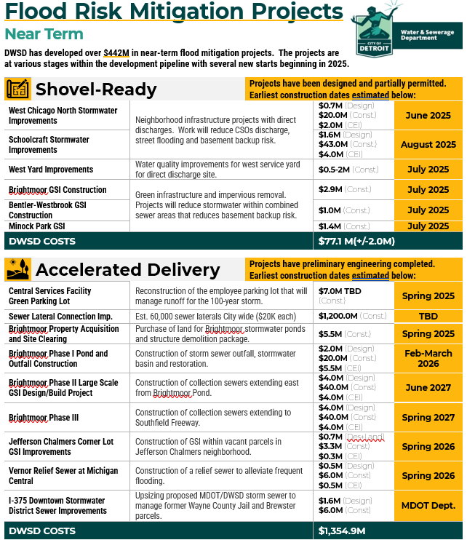
Note that the $1.2B for sewer lateral connection improvements is included in the unmet needs assessment under Section II.
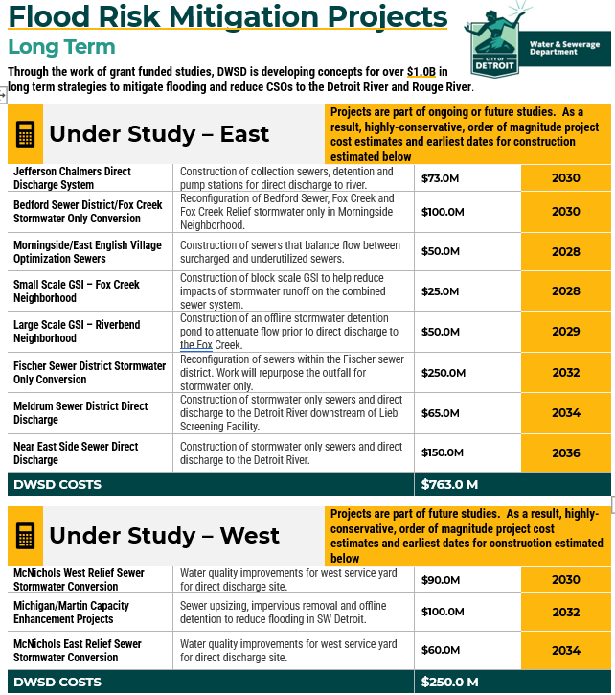

Allocation and Award Caps & Funding Criteria

All the CDBG-DR funding will be administered by the City of Detroit through its Housing and Revitalization Department (HRD), who is the responsible entity for this process. Funds being passed through to other entities as applicable are described below. The City will also be the Responsible Entity for the decision making and completion of environmental review per 24 CFR 58.4.
For all of the programs where there is a maximum amount of assistance (award cap), the City and its partners, when necessary, will adjust its award cap to comply with federal accessibility standards or to reasonably accommodate a person with disabilities. The City of Detroit and its partners will adopt policies and procedures that communicate how they will analyze the circumstances under which an exception is needed, and the amount of assistance necessary and reasonable. Those policies will reference and define a reasonable accommodation for eligible applicants as they related to each program.

Administration

Table IVA: Grantee Administration Activity(ies) Overview
Eligible Cost Category | CDBG-DR Allocation Amount | % of CDBG-DR Allocation
Administration Total: | $17,343,200 | 5%
Total | $346,864,000 | 100%

Planning

Table IVB: Grantee Planning Activity(ies) Overview
Eligible Cost Category | CDBG-DR Allocation Amount | % of CDBG-DR Allocation
Planning Activity Number One | $2,000,000 | 1%
Planning Total: | $2,000,000 | 1%
Total | $346,864,000 | 100%

Housing

Housing Programs Overview

Table IVC: Grantee Housing Programs Overview
Eligible Cost Category | CDBG-DR Allocation Amount | % of CDBG-DR Allocation for LMI Benefit
Housing Program Number One | $34,050,000 | 10%
Housing Program Number Two | $31,000,000 | 9%
Housing Program Number Three | $9,400,000 | 2%
Housing Program Number Four | $600,000 | 1%
Housing Program Total: | $75,050,000 | 22%
Total | $346,864,000 | 100%

Grantee Housing Program Number One

Program Title: Affordable Housing Development
Amount of CDBG-DR Funds Allocated to this Program: $34,050,000
Eligible Activity(ies): Housing Rehabilitation 24 CFR Part 570.202 and New Construction as waived per III.D.5 of the CDB-DR Universal Notice
National Objective: Low-to-Moderate Income Persons – Housing (LMH) 24 CFR 570.208(a)(3)
Lead Agency and Distribution Model: HRD will administer this program through eligible Developers. HRD will utilize its existing infrastructure for providing gap financing for the development of affordable housing, through its bi-annual competitive Notice of Funding Availability (NOFA) process. HRD has an existing multifamily underwriting team; CDBG-DR funds will be used to add capacity to this team as needed to support the volume of anticipated new project pipeline.
Program Description: This program will utilize CDBG-DR funds to invest as gap financing that will create disaster-resilient affordable housing that incorporates best practice stormwater management principles. The program will leverage other public and private investment in the developments to help create an estimated 700 affordable housing units that provide Detroit residents at 80% AMI or below with safe, quality housing.
Eligible Geographic Areas: City-Wide
Other Eligibility Criteria: Developers apply for funding for eligible affordable housing projects through the bi-annual NOFA. For projects that score competitively for City funding, HRD will make the determination on when and where to utilize CDBG-DR funding based on the project’s characteristics, most critically that the plans include adequate stormwater management design and the interaction with other project financing. NOFA criteria is subject to change, and information on how projects/applications will be scored and prioritized will be laid out in the NOFA. The City will encourage the participation of disaster impacted persons through outreach for this program.
Maximum Amount of Assistance Per Beneficiary: The following restrictions will be placed on funding allocations for the Affordable Housing Development Program: Maximum award per project: $1,000,000 for 9% LIHTC; $3,000,000 for all others* Maximum award per developer per round: $3,000,000*
Due to rising construction costs, HRD will consider on a case-by-case basis, requests above the $1,000,000 limit for 9% LIHTC projects and a maximum award above $3,000,000 per developer, per round if the applicant can demonstrate an increase in score through MSHDA’s QAP as a direct result.
Maximum Income of Beneficiary: 80% AMI
Mitigation Measures: This project does meet the definition of mitigation by providing quality and resilient affordable housing that will lessen the displacement impact of future disasters for City residents.
Reducing Barriers for Assistance: The City of Detroit will conduct proactive, strategic communication and program outreach throughout the life cycle of the program to ensure that barriers will be readily identified and reduced. The success of this communication and outreach will heavily depend on the levels of engagement from key community stakeholders and the City’s responsiveness to any and all identified issues.

Grantee Housing Program Number Two

Program Title: Affordable Public Housing
Amount of CDBG-DR Funds Allocated to this Program: $31,000,000
Eligible Activity(ies): Housing Rehabilitation 24 CFR Part 570.202(2) and New Construction as waived per III.D.5 of the CDB-DR Universal Notice
National Objective: Low-to-Moderate Income Persons – Housing (LMH) 24 CFR 570.208(a)(3)
Lead Agency and Distribution Model: HRD and DHC will enter into a subrecipient agreement for the program. DHC will oversee implementation of the projects. Qualified contractors/developers will have an opportunity to partner on projects via Request For Proposals (RFP). Each project will produce new housing units that are designated as deeply affordable and set aside for the city’s most vulnerable residents (very low income, at or below 30% AMI).
Program Description: The Detroit Housing Commission (DHC) will be rehabilitating and/or constructing public housing units or units served by project based rental assistance for rent by extremely low-income households. DHC is estimating that projects will have between 150-350 units each and include projects that have vacant units requiring rehabilitation due to deferred maintenance and/or age of properties. This will include infrastructure upgrades (i.e. water/sewer line replacements, green storm water infrastructure and greenspace) in order to support the addition of new units. The city has an aging public housing portfolio in need of modernization and climate resilient infrastructure upgrades to protect low-income residents from further exposure to potential climate-related damage to their housing. Due to the city’s poverty level and 36% rental rate of occupied housing, it is imperative that these funds be used to protect low-income renters from future catastrophic damage as weather events remain imminent. This program will serve residents at or below 30% AMI.
Eligible Geographic Areas: City-Wide
Other Eligibility Criteria: N/A
Maximum Amount of Assistance Per Beneficiary: It is anticipated that each project will not exceed $15,000,000 in CDBG-DR funding, unless otherwise authorized by HRD and DHC
Maximum Income of Beneficiary: 30% AMI
Mitigation Measures: Climate resilient affordable housing may help prevent future displacement by placing residents in newer housing units. Implementing these projects now reduces the potential impact of damage in the future, and bringing stronger housing units online allows DHC to move residents to better units and leverage that rental income to more quickly address capital repairs in its portfolio.
Reducing Barriers for Assistance: The City of Detroit will conduct proactive, strategic communication and program outreach throughout the life cycle of the program to ensure that barriers will be readily identified and reduced. The success of this communication and outreach will heavily depend on the levels of engagement from key community stakeholders and the City’s responsiveness to any and all identified issues.

Grantee Housing Program Number Three

Program Title: Down Payment Assistance
Amount of CDBG-DR Funds Allocated to this Program: $9,400,000
Eligible Activity(ies): Homeownership Assistance 24 CFR Part 570.201(n)
National Objective: Low-to-Moderate Income Persons – Housing (LMH) 24 CFR 570.208(a)(3)
Lead Agency and Distribution Model: The Housing & Revitalization Department (HRD) is responsible for several duties to ensure the Detroit Down Payment Assistance Program operates effectively and meets its intended goals, as follows:
- Selection and Management of Procured Contractors
- Program Design and Development
- Documentation and Record Keeping
- Financial Management
- Coordination with Private Sector Entities
- Legal Compliance
- Communication and Outreach
- Monitoring and Evaluation
- Reporting
- Program Efficiency and Improvement
- Default Management
- Asset Management

Through the City of Detroit procurement process, the selected Detroit Down Payment Assistance Program Administrator will be responsible for the following activities:
- Program Design
  - Preliminary program terms
  - Referral and intake process
  - Lender and stakeholder engagement
  - Marketing and outreach plan

- Program Implementation
  - Finalize program documents
  - Finalize program website

- Program Administration
  - Application Intake: The Program Administrator will be responsible for communicating with potential applicants and instructing them on how to apply for the program. The Program Administrator will receive and process all applications and review them for accuracy, completeness, and appropriate supporting documents necessary to determine eligibility.
  - Education: The Program Administrator will ensure that all applicants complete HUD homebuyer education.
  - Loan Prequalification: The Program Administrator will work with the Lender throughout the loan process and provide the Lender with all forms to be completed in conjunction with the City’s DPA program.
  - Underwriting: The Program Administrator will underwrite all City DPA grants/loans and adhere to all underwriting guidelines created for the program.
  - Loan Origination: The Program Administrator will work with the Lender throughout the loan origination process to ensure that the City’s DPA documents and other information are submitted to the first mortgage lender. The first mortgage loan package will be reviewed by the Program Administrator for compliance with the City’s DPA guidelines.
  - Loan Closing Process: The Program Administrator will facilitate the entire loan closing process and prepare and submit all applicable closing documents, including closing disclosures, deed of trusts, and promissory notes, in coordination with the City. The Program Administrator will be responsible for determining how all legal documents for the City’s DPA loans will be prepared.

- Evaluation & Modification
  - Interim and final evaluations, and submissions for any program modifications (if necessary).
  - Reporting. Adherence to all Department and Federal requirements including but not limited to data related to demographics, DPA usage, participating lender, homebuyer education agency, PITI, etc.

EVALUATION CRITERIA
Each criterion below will be scored on a numeric scale of 1-5, with a score of 5 representing “Exceptional” responses and a score of 1 representing “Weak” responses. Each of the criteria below are weighted by a certain percentage of the total score. Please see below a scoring guide for the evaluation process.
Criteria | Score Multiplier* | Max Points**
- Demonstrated understanding of the City’s scope of work. | (___ x 1) | 10
- Recent experience, qualifications, and key personnel in planning and designing homeownership programs. | (___ x 3) | 20
- Proposed approach to the Down Payment Assistance Program implementation and administration activities. Proposal contains all required scope of work elements. | (___ x 4) | 25
- Demonstrated experience administering homeownership programs. | (___ x 3) | 30
5. Experience designing/implementing housing programs with federal funds. | (___ x 2) | 15
TOTAL SCORE |  | 100

*This column provides a score multiplier for each criterion that represents how each category is weighted. Each criterion will get a score between 1-5 and then will be multiplied by the multiplier to get their final score for each category. For example, for the second category, if an application received a score of 3, the score would be 3 x 4=12 for this category.

**The scores in this column represent the maximum score for each criterion. If an application received the highest score for each criterion, their total score would be 65 points.
Program Description: The City of Detroit’s Detroit Down Payment Assistance Program aims to rebuild homeownership in Detroit. The program provides qualifying residents grants for down payments and prepaids, including interest rate buy down, closing costs, and principal reduction, in conjunction with purchasing a home using a purchase mortgage or a purchase renovation mortgage. The program is available to low-to-moderate income earners who may be able to afford a monthly mortgage payment, but don’t have savings enough for a down payment.
Eligible Geographic Areas: City-Wide
Other Eligibility Criteria: In addition to income eligibility, and the completion of a HUD approved homebuyer education class, additional program criteria for the Detroit Down Payment Assistance Program include: DPA award to not exceed 50% of the purchase price, Meet first time homebuyer criteria, Occupancy of the home as primary residence for 3 years, or pay back prorated rate, Contribution of at least $1,000 to closing, Housing ratio to not exceed 35%. Application criteria is subject to change, and information on how projects/applications will be scored and prioritized will be laid out in the application. The city will encourage the participation of disaster impacted persons through marketing and outreach of this program, and will prioritize these applications. Detroit DPA will add language to all outreach materials; presentations, flyers, and website, that encourages residents who were impacted by the 2023 flood to apply, and explains the flood impacted household prioritization. For flood impacted households, HRD will require proof of impact and these households will be moved to the top of the list for a DPA reservation number, which encumbers the funds.
Maximum Amount of Assistance Per Beneficiary: Not to exceed $25,000/household
Maximum Income of Beneficiary: 80% AMI
Mitigation Measures: N/A
Reducing Barriers for Assistance: The City of Detroit will conduct proactive, strategic communication and program outreach throughout the life cycle of the program to ensure that barriers will be readily identified and reduced. The success of this communication and outreach will heavily depend on the levels of engagement from key community stakeholders and the City’s responsiveness to any and all identified issues.

Housing Program Number Four

Program Title: Detroit Financial Empowerment Center (FEC)
Amount of CDBG-DR Funds Allocated to this Program: $600,000
Eligible Activity(ies): Housing Information and Referral Services 24 CFR 570.201(e)
National Objective: Low-to-Moderate Income Persons – Limited Clientele (LMC) 24 CFR 570.208(a)(2)
Lead Agency and Distribution Model: The City of Detroit, through the Housing and Revitalization Department, will make funds available through a Notice of Funding Availability (NOFA). A Subrecipient Agreement will be awarded to eligible Housing Information and Referral Agencies (i.e financial counseling services) based on information gathered and assessed through the NOFA process. Qualified subrecipients will be notified by email and/or by NOFAs posted on the City’s Oracle site.
Program Description: This program focuses on improving housing outcomes for low to moderate income households by addressing underlying financial barriers to housing stability and homeownership. This includes offering assistance to qualified residents such as 1) building credit, 2) reducing debt, 3) increasing savings, and 4) banking the unbanked, and 5) access to safe and affordable mortgage products.
Eligible Geographic Areas: City-Wide
Other Eligibility Criteria: Eligible NOFA applicants should be a community development organization that adheres to the Financial Empowerment Center Model Requirements which can be found here: https://fecpublic.org/about/
Residents will be able to access the program in two ways – make an appointment with the selected agencies directly, or via referral due to denial from an existing housing program or service (i.e. Down Payment Assistance (DPA)) due to underlying financial situations.
The city will encourage the participation of disaster impacted persons through marketing and outreach of this program and will prioritize these applications. The subrecipient (s) will be required to add language to all outreach materials; presentations, flyers, and website, that encourages residents who were impacted by the 2023 flood to apply, and explains the flood impacted household prioritization.
Maximum Amount of Assistance Per Beneficiary: N/A
Maximum Income of Beneficiary: 80% AMI
Reducing Impediments for Assistance: The City of Detroit will conduct proactive, strategic communication and program outreach throughout the life cycle of the program to ensure that barriers will be readily identified and reduced. The success of this communication and outreach will heavily depend on the levels of engagement from key community stakeholders and the City’s responsiveness to any and all identified issues.

Infrastructure

Infrastructure Programs Overview

Table IVD: Grantee Infrastructure Programs Overview
Eligible Cost Category | CDBG-DR Allocation Amount | % of CDBG-DR Allocation for LMI Benefit
Infrastructure Program Number One | $7,227,800 | 2%
Infrastructure Program Number Two | $25,000,000 | 7%
Infrastructure Program Number Three | $175,000,000 | 50%
Infrastructure Program Total: | $207,227,800 | 60%
Total | $346,864,000 | 100%

Grantee Infrastructure Program Number One

Program Title: Public Facility Rehabilitation – Homeless Shelters
Amount of CDBG-DR Funds Allocated to this Program: $7,227,800
Eligible Activity(ies): Public Facilities and Improvements 24 CFR 570.201(c)
National Objective: Low-to-moderate Income Persons – Limited Clientele (LMC) 24 CFR 570.208(a)(2)
Lead Agency and Distribution Model: The City of Detroit, through the Housing and Revitalization Department, will make funds available through a Notice of Funding Availability (NOFA) to award funds to eligible projects. Grants will be awarded to eligible Emergency Shelter Public Facility applicants for eligible activities based on an application process and awarded to the extent that funds are available. The City of Detroit will use NOFA packages to gather the information necessary to assess each project and potential subrecipient. Eligible applicants will be notified through direct emailing and by NOFAs posted on the City’s Oracle site and CDBG-DR website.
Program Description: This program will award funds to eligible projects within the City to address unmet recovery needs associated with emergency shelter public facilities impacted by the August 2023 flooding. The program defines public facilities as projects that improve emergency shelters owned by nonprofits that are open to the public and receive referrals from Detroit’s Coordinated Assessment Model (CAM). Funding and Program guidelines will further define eligible projects for applicants
Eligible Geographic Areas: Nonprofit operated Emergency shelters located within the boundaries of the City of Detroit will be eligible.
Other Eligibility Criteria: The application process will require applicants to demonstrate how their projects address unmet recovery and/or mitigation needs and how funds will be used equitably in their communities. Applications for funding may be evaluated on, but not limited to, the following project components: Amount of project detail provided and tieback to the disaster and community need, Project’s impact on unmet recovery needs or mitigation of future disasters, Applicants may not be presently debarred, suspended, proposed for debarment, declared ineligible, or voluntarily excluded from participation in federal programs, as indicated by the System for Award Management (www.sam.gov). NOFA criteria is subject to change, and information on how projects/applications will be scored and prioritized will be laid out in the NOFA.
Maximum Amount of Assistance Per Beneficiary: Projects under this NOFA will not exceed $5,000,000 unless authorized by HRD.
Maximum Income of Beneficiary: Beneficiaries are presumed benefit but anticipated to be at 30% AMI or below
Mitigation Measures: This project does meet the definition of mitigation as funds will allow recipients to make improvements to public facilities that will directly address unmet recovery needs and increase the resilience of the shelter facilities to lessen the impact of future disasters. Mitigation funds are included in the public facilities budget and may be used to support improvements to facilities that were not directly impacted by the flood event but increase the resilience of the facilities and reduce or eliminate the long-term risk of loss of life, injury, damage to and loss of property, suffering and hardship, by lessening the impact of future disasters.
Reducing Barriers for Assistance: The City of Detroit will conduct proactive, strategic communication and program outreach throughout the life cycle of the program to ensure that barriers will be readily identified and reduced. The success of this communication and outreach will heavily depend on the levels of engagement from key community stakeholders and the City’s responsiveness to any and all identified issues.

Grantee Infrastructure Program Number Two

Program Title: Brightmoor Stormwater Improvement Project
Amount of CDBG-DR Funds Allocated to this Program: $25,000,000
Eligible Activity(ies): Public Facilities and Improvements 24 CFR 570.201(c)
National Objective: Low-to-moderate income persons – Area Benefit (LMA) 24 CFR Part 570.208(a)(1)
Lead Agency and Distribution Model: DWSD will bid out a single construction contract. The contract will be inclusive of all elements needed to construct the stormwater sewer system and excavate the stormwater basin. This includes roadway removals, the new storm sewer outfall at Lyndon Avenue, storm sewer, utility relocations, mass grading and roadway restoration. DWSD will oversee this work providing construction engineering and inspection via an existing contract not funded with CDBG-DR.
Program Description Many residential neighborhoods across Detroit and public facilities experience recurrent basement backups due to a variety of factors. These can vary greatly from localized problems at homes (cracked sewer laterals) to regional sewer system failures (power loss and sewer capacity exceedance). Whatever the issue, significant rain events are causing basement backups across the City of Detroit resulting in widespread property damage and sometimes insurmountable repair and restoration costs to Detroit residents. In addition to property damage, the city experienced flooding of highways and streets due to aging infrastructure and climate change. Public facilities such as emergency shelters experienced flooding which forced some shelters to close and move to temporary locations.
Over the past 10 years, Detroit has experienced multiple rainstorms which exceed the design storm of the existing sewer system (10-year, 1-hour event) – these include August 11, 2014, June 25-26, 2021, July 16, 2021, August 29, 2021 and August 24, 2023. Each of these storms have resulted in basement backup claims within the City which harm residential properties and impose significant financial and social burdens. Although the location and intensity of these high-exceedance storms have varied across the city, the connected nature of the Detroit sewer system, which is all tributary to a single wastewater treatment plant, means that any project that removes stormwater will have benefit at both a neighborhood, citywide, and across counties. As seen in the 2021 storms in particular, the large volume of water that fell over the regional sewer system eventually flowed to the interceptors and regional pump stations. This ultimately overburdened Detroit neighborhoods at the bottom of the regional sewershed. As part of an ongoing resiliency strategy, Detroit and the Great Lakes Water Authority are working to find cost effective projects that work to remove stormwater from the regional sewer systems. This helps to create additional capacity at larger interceptors while also relieving local neighborhood infrastructure.
Eligible Geographic Areas: The project is bounded by the west by the Rouge River, north by Keeler Street, on the east by Evergreen Road and on the south by Lyndon Avenue. The project will serve the Brightmoor neighborhood.
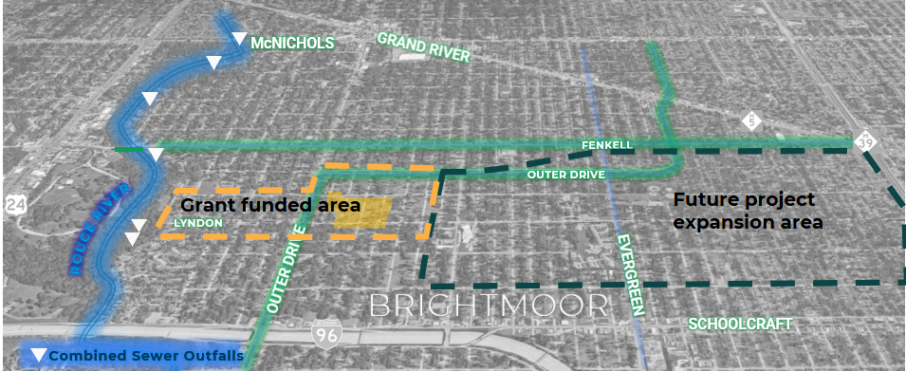

Other Eligibility Criteria: N/A
Maximum Amount of Assistance Per Beneficiary: This project is an area benefit, and not a direct benefit to a beneficiary.
Maximum Income of Beneficiary: At or below 80% AMI
Mitigation Measures: The project will significantly reduce the risk of future disasters by removing stormwater from the combined sewer system for residents and businesses within the Fenkell sewer district. The project is the continuation of over a decade of project work within the Upper Rouge Tributary drainage area. The removal of stormwater from the combined sewer system will have a significant impact in reducing basement backups and street flooding for increasingly recurrent intense summer storms. The sum of these actions is a more resilient regional sewer system resistant to future flooding. The project is listed within the City of Detroit Hazard Mitigation Plan (Page 136) as an implementation strategy to address flooding. The specific project (Flooding Action Item) is as follows: -Sewer separation projects to remove flow and reduce grade line at the following locations: Fischer, East English Village, Near-eastside separation, Puritan, Fenkell, Lyndon, Schoolcraft and W. Chicago
Reducing Barriers for Assistance: The City of Detroit will conduct proactive, strategic communication and program outreach throughout the life cycle of the program to ensure that barriers will be readily identified and reduced. The success of this communication and outreach will heavily depend on the levels of engagement from key community stakeholders and the City’s responsiveness to any and all identified issues.

Grantee Infrastructure Program Number Three

Program Title: City-Wide Alley Sewer Repair
Amount of CDBG-DR Funds Allocated to this Program: $175,000,000
Eligible Activity(ies): Public Facilities and Improvements 24 CFR 570.201(c)
National Objective: Low-to-moderate income persons – Area Benefit (LMA) 24 CFR Part 570.208(a)(1)
Lead Agency and Distribution Model: DWSD will assign various alley sewer repairs to qualified contractors to reconnect sewer lateral connections to the public sewer main that have either fallen off the public main, or that have collapsed altogether. DWSD will prepare and advertise competitive solicitations for contractors familiar with this type of underground work. DWSD anticipates that at least three contracts will be awarded.
Program Description: A failed connection to the public sewer main will allow sand, soil, roots, and grit to enter the public sewer main while also severely impeding flow from residential properties. This debris and sediment accumulate in the sewer mains, reducing flow capacity, increasing the likelihood of sewer surcharging that can lead to flooding and water in basement. As Detroit's sewer system and the resident-owned lateral sewers continue to age, these types of failures are becoming increasingly common. The effects of these failures can be realized during any wet weather event, however the severity of them is greatly increased during extreme wet weather events such as those experienced in 2016, 2021 and 2023. This activity will replace failed connections between the public sewers and private lines. The work will be done within the public right-of-way.
Eligible Geographic Areas: The project will be implemented citywide, within income service areas.
Other Eligibility Criteria: N/A
Maximum Amount of Assistance Per Beneficiary: This project is an area benefit, and not a direct benefit to a beneficiary.
Maximum Income of Beneficiary: At or below 80% AMI
Mitigation Measures: This project does meet the definition of mitigation, repairing or replacing sewer laterals may prevent future damage to residential homes, lessening the hardship cause to low-to-moderate income households who may not be able to afford insurance or afford to make those types of repairs without assistance. The activity that will take place as part of this project is included in the City of Detroit Hazard Mitigation Plan (Page 137) as an implementation strategy to address basement flooding. The specific project (Flooding Action Item) is as follows: Design and conduct a study to examine and refine flood mitigation strategies including increased inspections, storage, strategic sewer separation, and other potential strategies to significantly reduce wide-spread basement and street flooding. In addition, the improvements from this project will benefit areas downstream, by reducing sediment and other debris, as well as reducing the accumulation of debris within downstream pipes. The reduction in debris and grit will also benefit the regional wastewater treatment plant.
Reducing Barriers for Assistance: The City of Detroit will conduct proactive, strategic communication and program outreach throughout the life cycle of the program to ensure that barriers will be readily identified and reduced. The success of this communication and outreach will heavily depend on the levels of engagement from key community stakeholders and the City’s responsiveness to any and all identified issues.

CDBG-DR Mitigation Set-Aside

CDBG-DR Mitigation Set-Aside Programs Overview

The City of Detroit’s mitigation projects will increase resilience to disasters and reduce or eliminate the long-term risk of loss of life, injury, damage to and loss of property, and suffering and hardship by lessening the impact of future disasters. Incorporation of these measures also reduces costs in recovering from future disasters.
The City of Detroit mitigation activities will support long-term plans put in place by local and regional communities that promote the future well-being of these damaged areas by the hardening of infrastructure and public facilities so that communities withstand future disasters. The City of Detroit will coordinate with other local and regional planning efforts to leverage those efforts as much as possible. The City of Detroit is proposing to construct infrastructure and public facilities improvements as its mitigation activities. This activity will help prevent future impacts from flooding.

Table IVF: CDBG-DR Mitigation Set-Aside Allocation Summary
Eligible Cost Category | Unmet Need | % of Unmet Need | % of Funding to be Expended in HUD and Grante Identified MID | CDBG-DR Mitigation Set-Aside Allocation Amount | % of CDBG-DR Allocation Mitigation Set-Aside
Planning (15% cap) |  |  | 0% | $0 | 0%
Housing | Uknown | Unknown | 0% | $0 | 0%
Infrastructure | $1,244,900,000.00 | 100% | 100% | 45,243,000 | 100%
Economic Revitalization | Uknown | Uknown | 0% | $0 | 0%
Total | $1,244,900,000.00 | 100% | 100% | 45,243,000 | 100%
Funds that have not been allocated: |  |  |  | $0 | 0%
Grant Total (Recovery funds + Mitigation + Unallocated): |  |  |  | 346,864,000 | 100%

Table IVG: Grantee CDBG-DR Mitigation Set-Aside Programs Overview
Eligible Cost Category | CDBG-DR Mitigation Set Aside Allocation Amount | % of CDBG-DR Allocation for LMI Benefit | Does this Program have tie back to the disaster?
CDBG-DR Mitigation Set-Aside Standalone Program Number One | $20,000,000 | 100% | No
CDBG-DR Mitigation Set-Aside Standalone Program Number Two | $16,243,000 | 100% | No
CDBG-DR Mitigation Set-Aside Standalone Program Number Three | $9,000,000 | 100% | No
Total: | $45,243,000 | 100%

Grantee CDBG-DR Mitigation Set-Aside Program Number One

Program Title: Jefferson Chalmers Flooding and Floodplain Mitigation
Amount of CDBG-DR Funds Allocated to this Program: $20,000,000
Eligible Activity(ies): Public Facilities and Improvements 24 CFR 570.201(c)
National Objective: Low-to Moderate Income Persons – Area Benefit 24 CFR 570.208(a)(1)
Lead Agency and Distribution Model: HRD will allocate funding to the Detroit Building Authority (DBA), who will provide oversight of the project. The DBA will procure an engineering consultant team, who will manage the project, including procurement of contractors, pre-construction, construction and post-construction oversight.
Program Description: The city will install permanent fixtures for temporary stop logs (or other mitigation option) to keep flood water and Detroit River water out of the sewer system and adjacent properties. This permanent fixture (or other flood prevention devices) will aid in the removal of the floodplain designation in the Jefferson Chalmers neighborhoods and surrounding neighborhoods. The installation of the three (3) stop log structures will be across Lakewood, Phillip and Fox Creek canals, and include earthwork in Mariners, Riverfront - Lakewood East, AB Ford and Maheras Gentry Parks, and a floodwall at KAM Marine/Bayview Yacht Club.
[Excerpted from “Lake St Clair Flood Risk Reduction Study for the Jefferson-Chalmers Neighborhood, Detroit, Michigan U.S. Army Corps of Engineers (USACE) - Floodplain Management Services Program (FPMS) April 2022”] Water levels in the Great Lakes system have been rising substantially in the last few years. On Lake St. Clair, water levels have risen over five feet over the past seven years. The heavy precipitation in the winter and spring of 2019 has caused Lake St Clair’s water level to continue its rapid increase to an elevation higher than some of the coastal, canal front, and riverine shorelines throughout the City of Detroit.

This rise has increased the occurrence and magnitude of flooding in the densely populated neighborhoods along canals connected to Lake St. Clair. In response to the 2019 flooding, the City of Detroit utilized sand bagging techniques to build up shorelines and minimize the impacts of flooding as the situation worsened rapidly. However, these efforts were successful in mitigating all damages. In preparation for 2020 flooding, the City of Detroit employed additional temporary flood protection defenses, including HESCO barriers and Tiger Dam structures, along with sandbag structures, to provide additional protection to residences, public infrastructure, and public health in general. These measures are intended to mitigate flood damages in the short term, until a more permanent solution is developed and implemented in the Jefferson-Chalmers neighborhood.

In August of 2019, the City of Detroit requested USACE FPMS assistance for the identification of effective long-term flood mitigation measures in the Jefferson-Chalmers neighborhood in Detroit. This was initiated by both preliminary FEMA Flood Information Rate Maps (FIRM) (now final) that put more homes in the 1% flood zone, as well as experiencing flooding due to record high Great Lakes levels in 2019. This study is intended to be the first step in evaluating mitigation measures that can be utilized for a long-term solution to reduce flood risk due to coastal influences from Lake St. Clair and the Detroit River. This study does not evaluate severe storm events that result in interior drainage flooding. This FPMS study is designed to help inform the process undertaken by the City of Detroit to pursue the implementation of long-term solutions for flood mitigation efforts in the Jefferson-Chalmers area. This study looks at concept-level alternatives and does not provide a feasibility level solution, nor does it include design efforts.

There are many unknowns at this time related to the project. Prior to any construction beginning, the City will first procure a team of consultants and engineers to address subjects that must and will be studied, addressed and resolved during the project Preliminary Engineering phase. Approval by regulatory agencies such as EGLE, USACE, GLWA, FEMA, etc., are needed prior to proceeding with subsequent permitting and construction. These subjects include, but are not limited to:
- Environmental concerns like canal water stagnation while stop logs are deployed, possible Fox Creek sewer discharge while stop logs are deployed, possible existing sewer connections to the canals, historic hydrology and hydraulics in the area, existing contamination, possible impacts to wildlife, etc.
- Quality of life and economic issues like recreational enjoyment, watercraft access to the Detroit River, business disruption, etc.
In addition, the City is committed to exploring other mitigation alternatives during the Study and Preliminary Engineering phases.

Eligible Geographic Areas: This mitigation project will serve the neighborhoods bordered by Clairepointe Street (W), E. Jefferson Avenue (N), Alter Road (E), Detroit River (S), and will also provide relief to adjacent parcels to the north of E. Jefferson Avenue (Clairepointe to Alter) that are currently designated in the Special Flood Hazard Area (0.2% Annual Chance Flood).
https://hazards-fema.maps.arcgis.com/apps/webappviewer/index.html?id=8b0adb51996444d4879338b5529aa9cd (Type “Jefferson Chalmers, Detroit, MI” in search box - zoom to area – blue zone = Coastal Floodplain) roughly bounded by Conner/Clairpointe Avenues (West Boundary), E. Jefferson Avenue (North Boundary), Alter Road (East Boundary) and the Detroit River (South Boundary)
https://hazards-fema.maps.arcgis.com/apps/webappviewer/index.html?id=8b0adb51996444d4879338b5529aa9cd (Type “Jefferson Chalmers, Detroit, MI” in search box zoom to area – orange zone = 0.2% Annual Chance Flooding) roughly bounded by Conner Avenue (West Boundary), Kercheval Avenue (North Boundary), Alter Road (East Boundary) and E. Jefferson Avenue (South Boundary)

Other Eligibility Criteria: N/A
Maximum Amount of Assistance Per Beneficiary: This project is an area benefit, and not a direct benefit to a beneficiary.
Maximum Income of Beneficiary: At or below 80% AMI
Mitigation Measures: The project will prevent future flooding due to cyclical and rising Great Lakes levels and aid in the removal of FEMA floodplain designation for the entire Jefferson Chalmers neighborhood and adjacent neighborhoods as noted above. Installation of permanent structures for 3 stop log (aka “temporary, removable dam panel”) sites (or other mitigation option) across Lakewood, Phillip and Fox Creek canals. The stop logs will be installed temporarily during months of high Great Lakes levels, then removed and stored until needed again. Earthwork berms are proposed in Mariners, Riverfront - Lakewood East, AB Ford and Maheras Gentry Parks, and a floodwall at KAM Marine/Bayview Yacht Club is also proposed.

Reducing Barriers for Assistance: The City of Detroit will conduct proactive, strategic communication and program outreach throughout the life cycle of the program to ensure that barriers will be readily identified and reduced. The success of this communication and outreach will heavily depend on the levels of engagement from key community stakeholders and the City’s responsiveness to any and all identified issues.

Grantee CDBG-DR Mitigation Set-Aside Program Number Two

Program Title: Public Facility Rehabilitation – Homeless Shelters (MIT)
Amount of CDBG-DR Funds Allocated to this Program: $16,243,000
Eligible Activity(ies): Public Facilities and Improvements 24 CFR 570.201(c)
National Objective: Low-to-moderate Income Persons – Limited Clientele (LMC) 24 CFR 570.208(a)(2)
Lead Agency and Distribution Model: The City of Detroit, through the Housing and Revitalization Department, will make funds available through a Notice of Funding Availability (NOFA) to award funds to eligible projects. Grants will be awarded to eligible Emergency Shelter Public Facility applicants for eligible activities based on an application process and awarded to the extent that funds are available. The City of Detroit will use NOFA packages to gather the information necessary to assess each project and potential subrecipient. Eligible applicants will be notified through direct emailing and by NOFAs posted on the City’s Oracle site and CDBG-DR website.
Program Description: This program will award funds to eligible projects within the City to address mitigation needs associated with emergency shelter public facilities. The program defines public facilities as projects that improve emergency shelters owned by nonprofits that are open to the public and receive referrals from Detroit’s Coordinated Assessment Model (CAM). Funding and Program guidelines will further define eligible projects for applicants.
Eligible Geographic Areas: Nonprofit operated Emergency shelters located within the boundaries of the City of Detroit will be eligible.
Other Eligibility Criteria: The application process will require applicants to demonstrate how their projects address unmet recovery and/or mitigation needs and how funds will be used equitably in their communities. Applications for funding may be evaluated on, but not limited to, the following project components: Amount of project detail provided and tieback to the disaster and community need, Project’s impact on unmet recovery needs or mitigation of future disasters, Applicants may not be presently debarred, suspended, proposed for debarment, declared ineligible, or voluntarily excluded from participation in federal programs, as indicated by the System for Award Management (www.sam.gov). NOFA criteria is subject to change, and information on how projects/applications will be scored and prioritized will be laid out in the NOFA.
Maximum Amount of Assistance Per Beneficiary: Projects under this NOFA will not exceed $5,000,000 unless authorized by HRD.
Maximum Income of Beneficiary: Beneficiaries are presumed benefit but anticipated to be at 30% AMI or below
Mitigation Measures: This project does meet the definition of mitigation as funds will allow recipients to make improvements to public facilities that will directly address unmet recovery needs and increase the resilience of the shelter facilities to lessen the impact of future disasters. Mitigation funds are included in the public facilities budget and may be used to support improvements to facilities that were not directly impacted by the flood event but increase the resilience of the facilities and reduce or eliminate the long-term risk of loss of life, injury, damage to and loss of property, and suffering and hardship, by lessening the impact of future disasters
Reducing Barriers for Assistance: The City of Detroit will conduct proactive, strategic communication and program outreach throughout the life cycle of the program to ensure that barriers will be readily identified and reduced. The success of this communication and outreach will heavily depend on the levels of engagement from key community stakeholders and the City’s responsiveness to any and all identified issues.

Grantee CDBG-DR Mitigation Set-Aside Program Number Three

Program Title: Traffic Signal Connectivity and Power Backup System
Amount of CDBG-DR Funds Allocated to this Program: $9,000,000
Eligible Activity(ies): Public Facilities and Improvements 24 CFR 570.201(c)
National Objective: Low-to Moderate Income Persons – Area Benefit 24 CFR 570.208(a)(1)
Lead Agency and Distribution Model: The connectivity component of the project will be fully implemented by contractors, whose work will be procured and overseen by Department of Public Works (DPW) staff. The back up power sources and generator switches will be installed by procured contractors.
Program Description: During severe storm events, in addition to storm related flooding, there are often several power outages that cause traffic signals to go dark for significant periods of time. This program connects the balance of city jurisdiction traffic signals (230) to the centralized Traffic Management Center, so that all signals can be monitored and controlled remotely. This connectivity will allow for traffic signal malfunctions to be immediately noted in real time, thereby minimizing the time for traffic signals to be restored to full, safe operating status. This project also creates the capacity for signals to fully operate during power outages, by installing back power sources at key, high traffic intersections and outfitting all signals with quick connector switches that allow generators to be quickly connected during a loss of power. The implementation of this project will mitigate the impact of power outages created by future storm events.
Eligible Geographic Areas: City-wide (230 traffic signals).
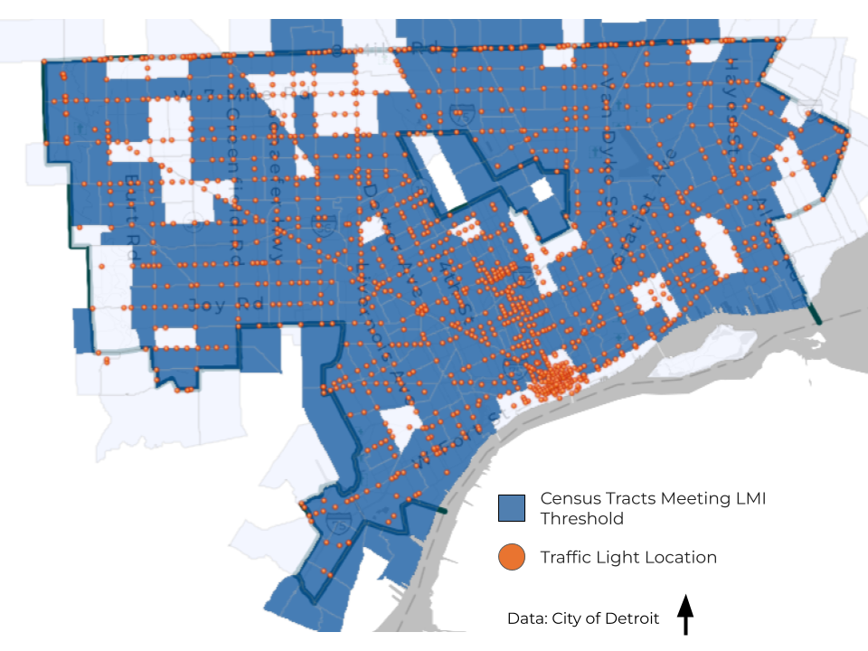
Other Eligibility Criteria: N/A
Maximum Amount of Assistance Per Beneficiary: There is no direct beneficiary, this program provides an area benefit.
Maximum Income of Beneficiary: At or below 80% AMI
Mitigation Measures: This project qualifies as a Mitigation project, as it will go a long way towards making intersections safer for vehicle operators and pedestrians during future storm events that result in the loss of power. It will lessen the impact of future disasters that cause power outages. It will reduce the risk of injury or loss of life, as high-volume traffic intersections will have working signals.
In 2024, there were 2419 separate instances of traffic signals malfunctioning; having traffic signals connected to our satellite Traffic Management Center allows these malfunctions to be noted in real time, and reduces the time required to repair the malfunction, and to restore the intersection to a safe condition with traffic signals operating in red, yellow, green.
In 2024, the city of Detroit had 234 separate incidents that resulted in loss of power to traffic signals. 71 of these power outages were due to storms, and an average of 18 separate traffic signals lost power during each reported power outage.
Reducing Barriers for Assistance: The City of Detroit will conduct proactive, strategic communication and program outreach throughout the life cycle of the program to ensure that barriers will be readily identified and reduced. The success of this communication and outreach will heavily depend on the levels of engagement from key community stakeholders and the City’s responsiveness to any and all identified issues.

General Information

Citizen Participation

Per the “Universal Notice” in the Federal Register (90 FR 1754), in order to permit a more streamlined process and ensure disaster recovery grants are awarded in a timely manner, HUD has waived requirements at 24 CFR 91.105(b) through (d) and replaced them with requirements found in section I.C.2 - “Citizen Participation Requirements”.
In addition, in order to ensure disaster recovery grants are awarded in a timely manner, the City of Detroit is waiving its requirements in its Citizen Participation policy found at #6 (Consideration of Public Comments) #9 (Publication of the Consolidated Plan, Annual Action Plan and Performance Reports) #10 (Public Hearings on the Consolidated and Action Plan), #11 (public Comment Period on the Proposed Consolidated and Action Plan) #12 (Substantial Amendments) for the CDBG-DR grant and is replacing them with the requirements below that align with the Citizen Participation Requirements in the Universal Notice.

Publication of the CDBG-DR Action Plan:
The City will publish a summary of the proposed CDBG-DR Action Plan on the City’s Disaster Recovery website. This summary will be a prominent posting and will describe the contents and purpose of the action plan. Copies of the complete proposed plan will be available in the offices of the Housing and Revitalization Department and on the City’s website. The City will publish all proposed Public Action Plan, amendments and public comments on the City disaster recovery website. Citizens, and other interested parties will have a reasonable opportunity to review the plan or substantial amendment.

Publication of the Action Plan and Opportunity for Public Comment:
Comments and opinions on the proposed CDBG-DR Action Plan will be considered by the City when preparing the final Action Plan. A summary of comments and views received will be attached to the final plan. A summary of the reasons for not accepting opinions or views not included in the plan will also be attached to the final plan. A draft will be available on the City’s Disaster Recovery website.
Citizens can provide comments by using the following methods:
- Via telephone: 1-313-224-6380, Hours: Monday to Friday from 8:30 am-4:30 pm
- Via email at: Disasterrecovery@detroitmi.gov
- In writing at: Housing & Revitalization Department, Disaster Recovery Team, 2 Woodward Ave, Ste. 908, Detroit MI, 48226
Meetings
The city will provide citizens with reasonable and timely access to local meetings on CDBG-DR Action Plan related matters. In many cases, public notice of these meetings will be given using the methods described in the above public hearing section.

Public Hearings
The City will follow the requirements of the City of Detroit Community Outreach Ordinance as applicable and/or hold at least two (2) public hearings to obtain citizen views and to respond to proposals and questions on the Action Plan per the requirements of the Universal Notice. Public hearings may be held virtually. If more than one public hearing is held in person, the City will hold each hearing in a different location that promotes geographic balance and maximum accessibility.
The City of Detroit will hold two city-wide public hearings to inform residents on the draft CDBG-DR action plan after being posted on the disaster recovery website. The City will post a notice of public hearings on the City’s CDBG-DR website. Public hearings will be held at a time convenient to potential and actual beneficiaries, and with accommodations for persons with disabilities or limited English proficiency (LEP).
Notice of these hearings will be published on the City’s Disaster Recover website at least one (1) day prior to the start of the public comment period, and the City will utilize one or more of the following methods of communication to inform residents such as: electronic mailings, press releases, statements by public officials, media advertisements, public service announcements and/or contacts with neighborhood organizations through the City Department of Neighborhoods.

Outreach and Engagement

The City of Detroit will hold 2 virtual public meetings, Citizens will be notified through the Housing and Revitalization Department’s GovDelivery email, social media public notice, media advertisements and through the City of Detroit’s Department of Neighborhoods.
In addition to the activities above, the City of Detroit will publish the action plan on the City of Detroit's Disaster Recovery webpage for a 30-day public comment period. Citizens will be encouraged to present their comments and opinions on the proposed plan at the public hearing, or by mail, email, or telephone directed to the offices of the Housing and Revitalization Department. Citizens will be notified via email blast at GovDelivery and Department of Neighborhoods listservs, social media outlets, and public service announcements.
Comments and opinions on the proposed action plan will be considered by the city when preparing the final action plan. A summary of comments and views received will be attached to the final plan. A summary of the reasons for not accepting opinions or views not included in the plan will also be attached to the final plan. A draft will be available on the City’s website. Citizens can provide comments via email at disasterrecovery@detroitmi.gov. For more information, citizens can refer to the City of Detroit's Citizen Participation plan at: https://detroitmi.gov/departments/housing-and-revitalization-department/disaster-recovery

City of Detroit Disaster Recovery Webpage
In accordance with Section II.A.1.c of the Universal Notice, the City of Detroit must have procedures to maintain a comprehensive public website that permits individuals and entities awaiting assistance and the public to see how all grant funds are used and administered. As a result of CDBG-DR funds being appropriated, the city has created a separate CDBG-DR webpage https://detroitmi.gov/departments/housing-and-revitalization-department/disaster-recovery.
The City’s CDBG-DR webpage will be updated on a regular basis (at minimum, quarterly) in accordance with established procedures and standards so that it will contain links to information regarding the use and management of grant funds. Links to all action plans and action plan amendments, performance reports, citizen participation notices, and program information for activities described in the action plan. Contracts and procurement actions that do not exceed the federal micro-purchase threshold, as defined in 2 CFR 200.1, are not required to be posted to the City's website.

Consultation of Developing the Action Plan
Consultation was held with the Detroit Housing Commission, Detroit Homeland Security and Emergency Management, Detroit Water & Sewerage Department, Detroit Department of Public Works, Detroit Office of Sustainability, along with over 270 contacts across 117 non-profit and community organizations.

Consideration of Public Comments

Public Comments are attached to this document as Exhibit A

Modifications to the Action Plan

A substantial amendment to the Action Plan will follow the same procedures for publication as the original Action Plan in accordance with the city’s Citizen Participation Plan. https://detroitmi.gov/sites/detroitmi.localhost/files/2023-01/Citizen%20Participation%20Plan%20-%20Revised%20%2810-17-22%29.pdf.
All amendments, both substantial and non-substantial, will be posted on the city’s CDBG-DR website. The beginning of every amendment will include a section that identifies the content that is being added, deleted, or changed. In addition, this section will include a revised budget allocation table that reflects the entirety of all funds and will clearly illustrate the movement or reallocation of program funding. The city’s most recent version of the entire Action Plan will be accessible for reviewing as a single document at any given time.

Substantial Amendment

When a substantial amendment to the action plan is being considered, a notice will be published on the City’s website and distributed via GovDelivery and Department of Neighborhoods list servs and social media outlets, in adherence with ADA and LEP requirements, that the city intends to amend the action plan. City of Detroit residents may request document translation and/or on-site interpreter services using the form link: https://app.smartsheet.com/b/form/f2386a588787406aaa0268b05441a219. The City of Detroit will follow the procedure outlined in the Citizen Participation Plan. This notice will describe the amendment and indicate how citizens may comment on it. A period of at least 30 days of the posting will be provided for citizens to comment on the amendment before it is an implemented substantial amendment. The City will consider, review, and respond to all public comments and views received on proposed substantial amendments and submit to HUD for approval. A summary of these comments and views will be attached to the substantial amendment. If comments and views are not accepted, the reasons for not accepting them will be summarized and attached to the substantial amendment.
At a minimum, the following modifications will constitute a substantial amendment:
- A change in the program’s benefit or eligibility criteria.
- the addition or deletion of an activity.
- a proposed reduction in the overall benefit requirement, or
- A reallocation which constitutes a change of 25 percent or greater of a program budget (the four major program areas area Housing, Infrastructure, Economic Development and Planning)

Nonsubstantial Amendment

Although non substantial amendments do not require HUD’s approval or seek public comment to become effective, the City will notify HUD of any plans to make an amendment that is not substantial. The City will notify HUD five (5) business days before the change is effective.
The city understands that the DRGR system must approve the amendment to change the status of the Public Action Plan to ‘‘reviewed and approved.’’ The DRGR system will automatically approve the amendment by the fifth day, if not completed by HUD sooner.

Performance Reports
The City of Detroit will assign a Project Manager who will oversee the development and submission of quarterly progress reports (QPR’s) for CDBG-DR. This Program Manager will work with partners, subrecipients, developers and/or contractors to collect applicable data and narratives for the QPR and will be trained to upload and submit information into HUD’s Disaster Recovery Grant Reporting (DRGR) system within 30 days of the end of each quarter. All approved QPR’s will then be posted by the Program manager or designee to the Disaster Recovery webpage.

Complaints
The city will respond to written complaints related to the CDBG-DR Action plan and substantial amendments in a timely manner. Complaints are encouraged to be submitted via email at disasterrecovery@detroitmi.gov but may also be submitted via telephone at 313-224-6380 or by mail to:
City of Detroit
2 Woodward Ave.
Suite 908. Housing and Revitalization Department (HRD)
Detroit, MI 48237.

Formal complaints may be made in person at public meetings and hearings, by mail, email and by telephone to the offices of the Housing and Revitalization Department (HRD). Response to written complaints will be made in writing within 30 days, where practical. Persons with complaints will be encouraged to put such complaints in writing with appropriate documentation. Informal complaints may be oral complaints at public hearings, meetings, and by telephone. When possible, City staff will try to respond orally to such complaints immediately. In some instances, people making oral complaints will be asked to put the complaint in writing with appropriate documentation. In other instances, the City has and will respond within 30 working days either orally or in writing as appropriate and convenient.
Owners of property assisted with CDBG-DR funds will also be provided with opportunities to appeal the quality of work on their properties. The CDBG-DR Program Manager or their designee will review the appeal, and then either approve or deny the appeal. The owner will be notified in writing of the decision made within 30 days of the appeal. If the owner is not satisfied with the decision, the appeal is escalated to the Director of the Housing and Revitalization Department, where the Director has the final say. There's a limited time to respond to the appeal and all responses are provided in writing.
A record of each filed complaint or appeal is kept in an information file. When a complaint or appeal is filed, HRD will respond to the complainant or appellant within 30 business days where practicable. For expediency, HRD will utilize telephone communication as the primary method of contact, email and postmarked letters will be used as necessary to document conversations and transmit documentation. Information about the right and how to file a complaint shall be printed on all program applications, guidelines, and HRD's public website for CDBG-DR in all local languages, as appropriate and reasonable. Procedures for appealing an HRD decision on a complaint shall be provided to complainants in writing as part of the complaint response.

Exhibit A – Public Comments

City of Detroit
Housing & Revitalization Department
Record of Public Hearing

Purpose: To receive citizen comments on the 2023 CDBG-Disaster Recovery Action Plan

Participants: Housing & Revitalization Department, Department of Neighborhood, and Detroit Housing Commission

CITIZEN PARTICIPANTS
150 Participants 8/11/25
140 Participants 8/25/25

Location: Virtual Citywide DON Cast Meeting (Zoom)

Date & Time: August 11th 5:00 pm – 7:00 pm
August 25th 5:00 pm – 7:00 pm

Summary and Response of Public Comments
Public Hearing Question/Comment: There are those non-profit partners we see a lot and I just don't understand the need for $6 million to go towards an FEC. I know it's not your issue, and I really wish that Julie or Tara had been here, because when I think of nonprofit partners as a person on the COC, I think of all the ones that are not doing what they are supposed to. HRD gave Detroit Rescue Mission $387,000 towards a shelter at 15063 Gratiot Avenue that should not be open. It failed every inspection. I have repeatedly reached out to HRD about it. Nobody vets him, nobody background checks him. Right now, he is under investigation, allegedly, by the FBI. I have gone through the 990s. There has been money pilfered out of there. Nobody in HRD can tell me where it went, other than “we do background, and we do oversight”. I have created a whole Google Drive of information that HRD didn't check. So, what I guess I'm wondering is. What happens if we say we don't want this money to go there? Are you all going to put it there anyway? Because I'm not confident in this.

Response to Question/Comment: Financial Empowerment Center funding is $600,000. I think you're speaking more to PFR homeless shelters. There is $7.2 million, and another $16.2 million that's allocated towards those activities. These are different non-profit organizations. This one is really tied to homebuyer and financial counseling for residents. When we put an application out, there is a capacity review that happens anytime we do a NOFA and identify a subrecipient.

Public Hearing Question/Comment: I really am having a hard time getting an answer to this question for the people HUD doesn't answer the phone. I'm the CEO of a non-profit who's trying to help the people right now, but here or there. The question is, we're trying to find housing. The landlords are demanding, requesting that one's income be three times the amount of the rental rate. And they're turning them down with these vouchers. I'm not sure if you guys have the answer to that question, but is there a rule or a law? MSHA only allots a person.. I don't even know the amount, I'm going find out, but from what I've heard, if one makes too much, they're not eligible for a housing choice voucher, a Section 8 voucher. And these landlords are telling the people, yeah, we'll take your voucher, but your income must be 3 times the amount of our rent.
Response to Question/Comment: So, I probably need to learn more about the situation you're describing. You can't be charged more than 30% of your income. And there’s a whole certification process that has to go on of the income. What you're saying doesn’t sound consistent with the rules, and so I’m going to put my email in chat. And you can send me this question, and I'll have our team from Leased Housing respond to it.
Public Hearing Question/Comment: Okay, I've been on a lot of these. I've been trying to get help, basically, for the last 5 years. I don't know if you all can help me, but I think so because you mentioned shelters with, Wayne Metro. They've been in my home for 5 years and I found out back in the end of 2023 that it was asbestos in my home the whole time. They were coming in here my children and I were in here every time. They gutted out my basement, they did the weatherization, all that, and the whole time, they blew the fans through. Every time, everything they did my children and I were in here. They did my plumbing, started back in COVID in 2020, and I'm still having breathing problems, as well as my daughter. You would have thought we had COVID when they gutted out our basement. And it's like, I can't get any help from no one because Wayne Metro is running the whole city of Detroit.
Response to Question/Comment: I just put my email into the chat. Can you email me directly so I can connect you with the right resources or the right point of contact for the issues you're dealing with?
Email Question/Comment:
I’m a disabled resident here in Detroit. I understand that infrastructure is important, but HUD requires that these funds address unmet housing needs for low-and moderate-income people. I am below the poverty line, as are many of my neighbors. The roof on my house leaks and sags, allowing water to enter the house. Between this and the two unfinished areas of my home, it's not safe for me to live in.
I’m asking the City to amend the Action Plan to allocate more funds directly to critical home repairs for low-income and disabled residents, including items such as roof replacement, plumbing, electrical work, and accessibility improvements. Additionally, my area near Midland Street resembles a walking dumpster—trash is everywhere. We need neighborhood cleanup and revitalization, so people aren’t forced to live surrounded by blight. Please ensure that this plan establishes a dedicated program to help people like me stay in safe homes and to clean up our neighborhoods.
Response to Question/Comment
Thank you for sharing your concerns with us. We hear you, and we know how important it is for Detroit residents to have safe, stable, and accessible homes. HUD requires that CDBG-DR funds be used solely for damage caused by the 2023 disaster. Most owners were affected by flooding during the August 2023 event.
The City of Detroit offers several programs that may help:
- Critical Home Repair Program – Focuses on urgent repairs that affect health and safety, like leaking roofs, unsafe electrical systems, or plumbing issues.
- Housing Rehabilitation Program – Provides help with major home repairs such as roofing, plumbing, and electrical work.
- Disability Assistance – Supports accessibility improvements so residents with disabilities can safely remain in their homes.
You can learn more or apply at:
- Critical Home Repair Program: Visit here
- Housing Rehabilitation Program: Visit here
For direct help, call the City of Detroit Housing & Revitalization Department at (313) 224-6380. Staff can answer your questions and guide you through the application process.

WXYZ Detroit – “Photo Gallery – Major storms cause flooding across Metro Detroit”
From the Great Lakes Water Authority (GLWA) Rain Gauge Data
2023 Detroit CoC Point-in-Time Count https://static1.squarespace.com/static/5344557fe4b0323896c3c519/t/6466684d3cc8374754b7f6d7/1684432974058/2023+Detailed+PIT+Report+Finaldg.pdf
2023 Detroit CoC Housing Inventory Count, Summary Data Report chrome-https://static1.squarespace.com/static/5344557fe4b0323896c3c519/t/6466673283fa8734f3a8c764/1684432690419/2023+DETROIT+COC+HIC+SUMMARY+W+CHRONIC+DETAILS_.pdf
US Census Bureau. 2021 American Community Survey
Detroit Office of Homeland Security & Emergency Management. City of Detroit Hazard Mitigation Plan, January 2022. by Detroit Office of Homeland Security & Emergency Management.2022.https://detroitmi.gov/sites/detroitmi.localhost/files/2022-02/Detroit%20HMP2021%20FullPlan_FINALDraftPublicPost_2.3_0.pdf
Detroit Office of Homeland Security & Emergency Management. City of Detroit Hazard Mitigation Plan, January 2022.pg 5. https://detroitmi.gov/sites/detroitmi.localhost/files/2022-02/Detroit%20HMP2021%20FullPlan_FINALDraftPublicPost_2.3_0.pdf
Detroit Office of Homeland Security & Emergency Management. City of Detroit Hazard Mitigation Plan, January 2022, https://detroitmi.gov/sites/detroitmi.localhost/files/2022-02/Detroit%20HMP2021%20FullPlan_FINALDraftPublicPost_2.3_0.pdf
Detroit Office of Homeland Security & Emergency Management. City of Detroit Hazard Mitigation Plan, January 2022,pg 36-38. https://detroitmi.gov/sites/detroitmi.localhost/files/2022-02/Detroit%20HMP2021%20FullPlan_FINALDraftPublicPost_2.3_0.pdf
Detroit Office of Homeland Security & Emergency Management. City of Detroit Hazard Mitigation Plan, January 2022. Pg.40-42. https://detroitmi.gov/sites/detroitmi.localhost/files/2022-02/Detroit%20HMP2021%20FullPlan_FINALDraftPublicPost_2.3_0.pdf

